IMPLEMENTATION OF A WEB-BASED STUDENT ACADEMIC RECORDS AND SERVICE MANAGEMENT SYSTEM FOR SENIOR HIGH SCHOOL AT CEBU FAR EAST INSTITUTE

A Capstone Project Proposal Presented to the
Faculty of the College of Computer Studies
Benedicto College - Mandaue Campus
A.S Fortuna St. Mandaue City, Cebu

In Partial Fulfillment of the Requirements for the Degree of
Bachelor of Science in Information Technology

Cejuela, Jake
Chan, John Raymond
Deximo, Shun
Limbaga, Theresa Marie
Quinto, Kenneth Daniel
Tomaquin, Zoilo

November 2026
Chapter 1
THE PROBLEM AND ITS SCOPE
Rationale
The integration of information technology in educational institutions has significantly improved how academic records and student services are managed. However, at Cebu Far East Institute (CFEI), Senior High School students are still required to personally visit designated school offices to access important academic information such as grades, study loads, tuition balances, and to request official documents. This process results in repeated manual inquiries, increased workload for school personnel, and delays in accessing student-related information.
Teachers also face challenges in managing and submitting student grades efficiently, as the current process lacks a structured digital workflow. Administrators, on the other hand, must handle student records, document requests, enrollment, and announcements manually through fragmented processes.
To address these concerns, this study proposes the development of INFORM — a Web-Based Student Academic Records and Service Management System for Senior High School at CFEI. The system provides a centralized and secure online platform where students can access their grades, study loads, class schedules, tuition balances, and request official documents anytime through an internet connection. It also provides teachers with a structured grade management workflow and gives administrators centralized control over student records, enrollment, document processing, and announcements.
Theoretical Background
The Information System Theory (Leavitt & Whisler, 1958) explains how the integration of people, technology, and processes facilitates the collection, processing, storage, and dissemination of information within an organization. According to Leavitt and Whisler (1958), information systems play a vital role in decision-making by converting raw data into meaningful information that supports management and operational activities. This theory emphasizes the importance of designing systems that ensure data accuracy, timeliness, and accessibility, allowing institutions to achieve efficiency and effectiveness in their daily operations.
In relation to the proposed Web-Based Student Academic Records and Service Management System, this theory highlights how a well-structured information system can streamline academic record and student service management. By providing a centralized platform, the system allows students to access grades, study loads, balances, announcements, and other student-related information efficiently. This not only enhances data reliability but also simplifies administrative processes, promoting transparency and efficiency between students and school personnel.

Systems Theory (Ludwig von Bertalanffy, 1968). Systems Theory views an organization as a collection of interrelated and interdependent parts working together to achieve a common goal. According to Bertalanffy (1968), the success of a system depends on the harmony and functionality of its subsystems. When applied to digital environments, this theory emphasizes that every component whether human, software, or hardware must work cohesively to ensure smooth operation and optimal results.
The proposed Web-Based Student Academic Records and Service Management System embodies this theory through its interconnected modules such as login authentication, academic record access, announcement management, and dashboard navigation. Each module functions as a subsystem that contributes to the overall performance of the system. When these components interact effectively, the system ensures that information flows seamlessly, improving user experience and operational efficiency.

Human - Computer Interaction (HCI) Theory (Card, Moran, & Newell, 1983) examines how people interact with computer systems and how design elements can improve usability, accessibility, and satisfaction. According to Card, Moran, and Newell (1983), an effective system must balance functionality and user experience to ensure that users can complete their tasks easily and intuitively. HCI theory also highlights the importance of feedback, simplicity, and clarity in system interfaces.
Applied to the proposed Web-Based Student Academic Records and Service Management System, this theory ensures that the system is user-friendly, accessible, and efficient for students, teachers, and administrators. The system presents information in a structured and understandable web-based interface, allowing users to navigate features and access services conveniently. By prioritizing usability, clarity, and accessibility, the system minimizes user confusion and improves overall user experience in accessing academic records and student-related services.

Management Information System (MIS) Theory (Davis & Olson, 1985) focuses on how computer-based systems support organizational management by providing accurate, relevant, and timely information for planning and decision-making. Davis and Olson (1985) assert that MIS helps organizations achieve efficiency by automating information flow and minimizing redundant manual processes. The theory also underscores the role of technology in improving productivity and decision accuracy.
For the proposed Web-Based Student Academic Records and Service Management System, the MIS Theory is relevant because the system functions as an academic management and student service tool. It automates the retrieval and management of student information, allowing students, teachers, and administrators to access accurate data quickly and efficiently. This automation minimizes clerical errors and enhances the institution’s ability to maintain consistent and updated records, aligning with the principles of effective information management.

Data Security Theory (Baskerville, 1993) emphasizes the protection of information from unauthorized access, modification, or destruction. Baskerville (1993) explains that information systems must uphold three key security principles: confidentiality, integrity, and availability. These ensure that sensitive information remains private, unaltered, and accessible only to authorized users. The theory highlights that security mechanisms must be proactive to prevent data breaches and maintain trust between users and system administrators.
In the proposed Web-Based Student Academic Records and Service Management System, this theory is reflected in the system’s security features such as secure login authentication, password protection, restricted access, and centralized database security. These measures protect student information from unauthorized access while maintaining user confidence in the system. By prioritizing data protection and privacy, the system fosters a secure environment that aligns with institutional goals for security, accountability, and efficient information management.

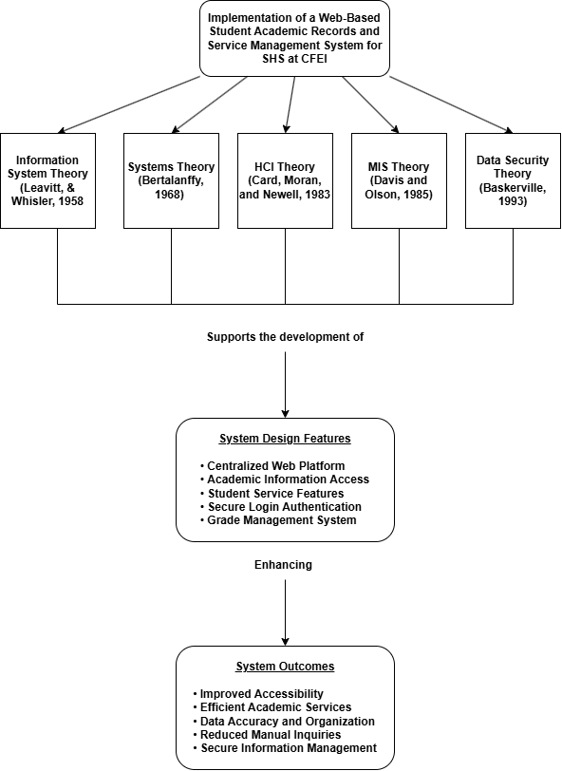

Figure 1
Theoretical Framework
Statement of the Problem
Senior High School students at Cebu Far East Institute (CFEI) lack a centralized online platform for accessing academic records and student-related services. This results in repeated manual inquiries, delays in retrieving information, and increased workload for school personnel who must respond to the same requests through fragmented, office-based process.
Specifically, this study seeks to answer the following questions:
- What are the current challenges faced by SHS students, teachers, and administrators in accessing and managing academic records and student services at CFEI?
- What features and functionalities are necessary in a web-based system to effectively centralize the management of student academic records and services for Senior High School?
- How will the proposed system improve the accessibility and efficiency of managing student academic records and services compared to the current manual process?
- To what extent does the proposed system meet the needs of students, teachers, and administrators in terms of usability, security, and functionality?

General Problem of the Study
The absence of a centralized and accessible online platform for managing student academic records and services at Cebu Far East Institute (CFEI) results in repeated manual inquiries, delays in retrieving academic information, and increased workload for both students and school personnel.

Specific Problem of the Study
1. What are the challenges faced by Senior High School (SHS) students, teachers, and administrators in accessing and managing academic records and student-related services at Cebu Far East Institute (CFEI)?
2. What features are needed in a web-based system to centralize and improve the management of student academic records and the delivery of student-related services?
3. How will the proposed system improve the accessibility and efficiency of managing student academic records and services compared to the current manual process?
4. To what extent does the proposed system meet the needs of students, teachers, and administrators in terms of usability and functionality?

General Objective of the Study
The study aims to develop and implement INFORM, a Web-Based Student Academic Records and Service Management System that provides Senior High School (SHS) students, teachers, and administrators of Cebu Far East Institute (CFEI) with a centralized, secure, and accessible online platform for managing academic records and student-related services.

Specific Objectives of the Study
Specifically, this study aims to:
- Identify the current challenges in accessing and managing student academic records and services among Senior High School (SHS) students, teachers, and administrators at Cebu Far East Institute (CFEI).
- Design and develop a web-based system that allows SHS students to securely access their grades, class schedules, study loads, tuition balances, and announcements through an online portal.
- Implement a structured grade management workflow that enables teachers to accept grade requests, compute grades, and submit them for administrative verification before releasing them to students.
- Provide administrators with centralized tools for managing student enrollment, grade verification, document request processing, tuition records, and school announcements.
- Evaluate the effectiveness of the proposed system in improving the accessibility, accuracy, and efficiency of student academic record management and service delivery at Cebu Far East Institute (CFEI).

Scope and Limitation of the Study
Scope
The study focuses on the design and development of INFORM, a Web-Based Student Academic Records and Service Management System for Senior High School students and personnel at Cebu Far East Institute (CFEI).
The system serves three primary user groups: students, teachers, and administrators. Students can securely log in to access their grades, class schedules, study loads, tuition balances, announcements, and submit requests for official documents such as the Transcript of Records, Certificate of Enrollment, and Good Standing Certificate. The system also includes JOBERT, an AI-powered chat assistant that responds to student inquiries regarding grades, tuition, and enrollment through the online portal.
Teachers can manage and process student grade requests through a structured multi-stage workflow: student request, teacher grade computation, registrar view, principal approval, register release, and final teacher release of grades to the student. Teachers can also monitor student attendance and manage document endorsements.
Administrators have centralized access to student and teacher records, enrollment management, grade request verification, document request processing with release date assignment, tuition monitoring, and school-wide announcement management. The system also includes a teacher time log feature that allows teachers to record their daily time in and time out entries during campus hours. These administrative functions are distributed across distinct Registrar, Principal, Accounting, and General Administrator roles, each with role-based access to its respective functions.
The system incorporates data privacy measures in compliance with the Data Privacy Act of 2012 (Republic Act No. 10173). Access to student records is restricted based on user roles through secure login authentication, and all user passwords are encrypted to protect sensitive academic information from unauthorized access.
Limitation
The proposed system is limited to the management and display of student academic records and selected student-related services for Senior High School at Cebu Far East Institute (CFEI). It does not process online payments or financial transactions; it only displays tuition balances and payment status.
The system does not perform automatic grade computation. Teachers are responsible for manually computing final grades before submitting them through the system. The grade management module facilitates the workflow and approval process rather than performing the grade calculations. The teacher time log module currently stories entries on the teacher’s own device rather than in the central database. Extending it to a shared, database backend feature that administrators can monitor centrally is intended as future work.
The system requires a stable internet connection and accurate data entry from authorized users. Any interruption in internet connectivity or incorrect data input may affect the reliability and accuracy of the system. Access is strictly limited to registered user students, teachers, and administrators with valid system accounts.
Significance of the Study
The Web-Based Student Academic Records and Service Management System provides several benefits to different stakeholders within educational institutions.
For School Administration, the proposed system helps improve the organization, accessibility, and management of student records through a centralized database system. It reduces administrative workload, improves record accessibility, and minimizes the risks of data loss, duplication, and manual processing errors.
For Educational Institutions, the implementation of the proposed system supports the modernization of academic services through the integration of web-based technologies in managing student information and student-related services. It promotes efficiency, accessibility, organization, and improved delivery of academic services.
For Teachers, the system allows authorized teachers to input and manage student grades through a centralized platform. This improves the efficiency and accuracy of recording student performance while minimizing paperwork and delays in grade processing.
For Students, the system provides a convenient and accessible platform for viewing academic information such as grades, enrolled subjects, study loads, tuition balances, announcements, and other relevant records online. This allows students to monitor their academic progress more efficiently while reducing the need for repetitive manual inquiries and office visits.
For Future Researchers, this study may serve as a reference for future studies related to web-based student information systems, academic record management, and student service platforms. The study may also provide insights into how web-based technologies can improve accessibility, organization, and management of student-related information and services.

Chapter 2
REVIEW OF RELATED LITERATURE

Related Literature
“Designing and Implementing E-School Systems: An Information Systems Approach to School Management of a Community College in Northern Mindanao, Philippines” by Grepon et al. (2021) The study discussed the development of an e-school system designed to address the lack of computerized platforms for managing student records and school-related services. The researchers found that the system improved the efficiency of school transactions and centralized the management of academic information. The study also emphasized the importance of web-based platforms in improving accessibility and communication among students, teachers, and administrators. This literature supports the present study because it demonstrates how digital systems improve the accessibility, organization, and management of student academic information and services within educational institutions.
In the article “Student Registration and Records Management Services Towards Digitization” by Falolo, Capillas, Vergarra, and Cerbito (2022) The significance of digitizing student record management systems in educational institutions was discussed. The authors emphasized that delays in retrieving academic records often occur when paper-based record management systems are utilized. The article also highlighted the possibility of data inaccuracies and inefficiency when manual systems are used. Furthermore, the study emphasized the importance of implementing digital and web-based systems to improve accessibility, organization, and management of academic information. This literature is relevant to the proposed Web-Based Student Academic Records and Service Management System because it highlights the need for centralized digital platforms that improve accessibility, accuracy, and efficiency in managing student academic records and services.
Daim, Gungor, Basoglu, Yarga, and VanDerSchaaf (2024), in their research entitled “Exploring Student Information Management System Adoption Post Pandemic: Case of Turkish Higher Education,” investigated the role of higher educational institutions in managing student information using student information management systems. The research concluded that such systems help store and process information regarding student details, course schedules, grades, and financial information while reducing administrative workload. The study also highlighted the significance of digital systems in improving accessibility, accuracy, and efficiency of information management. This literature is relevant to the proposed system because it emphasizes the importance of web-based student information systems in improving the management and accessibility of academic records and student-related services.
In the article “Management of Educational Institutions through Information Systems for Enhanced Efficiency and Decision-Making,” Sunarjo, Chakim, Maulana, and Fitriani (2024) discussed the importance of information systems in improving the efficiency of educational institutions. The authors explained that digital information systems facilitate the effective management of academic information while enhancing communication among students, teachers, and administrators. The article concluded that implementing information systems improves efficiency, accessibility, and decision-making processes within educational institutions. This literature is relevant to the proposed Web-Based Student Academic Records and Service Management System because it highlights the advantages of implementing centralized and web-based information systems for managing academic information and student-related services.
In the article “The Role of Centralized Databases in Modernizing Campus Infrastructure,” Balcita and Palaoag (2020) examined the relationship between technological facility upgrades and student outcomes. The researchers found that deploying an integrated school management network build on a consolidated data architecture improved the quality of institutional operations. The study concluded that modernizing campus networks improves service delivery and reduces administrative bottlenecks. This literature is directly relevant to the proposed system because it underscores the necessity of moving away from manual setups toward unified data frameworks to maximize service efficiency.

Related Studies
The study “Design and Implementation of a Student Information System by Ike (2023),” developed a computerized system for managing student academic records through a centralized database. The results showed that implementing the system improved the accuracy of student information and reduced the time required to retrieve academic records. The study concluded that automated systems improve administrative efficiency in educational institutions. This study supports the proposed Web-Based Student Academic Records and Service Management System because it highlights the importance of centralized and automated systems in improving accessibility, organization, and management of student-related information and services.
The study “IntelliSchool: A Student Information System for Senior High School by Campanan et al. (2024),” developed a web-based platform for managing student academic records and grading information. The system allowed teachers to input grades and enabled students to access their academic records online. The findings showed that the system improved transparency, accessibility, and efficiency in managing student information. This study supports the development of the proposed system because it demonstrates the effectiveness of web-based student information systems in providing centralized and accessible academic services.
The study “Design and Testing of a Web-Based Student Information Management System by Pasaribu and Argadikusuma (2024),” developed a digital platform that allows institutions to manage student academic records through an online database. The researchers found that the system improved the efficiency of managing student data and allowed faster retrieval of academic information. The study also highlighted the importance of web-based technologies in improving accessibility and management of academic services. This study supports the present research because it demonstrates the advantages of implementing web-based systems for managing student academic records and services.
The study “Development of a Student Records Management System” by Duruin (2024) focused on designing and implementing a computerized platform for managing student academic records. The researcher applied the Software Development Life Cycle (SDLC) in developing the system. The results showed that the developed system improved the efficiency of storing, retrieving, and managing academic records compared to manual record management. The study also highlighted the effectiveness of digital systems in improving accessibility and organization of student information. This study supports the present research because it demonstrates how web-based and centralized systems improve the management of student academic records and services. .
Another local study entitled “Development of a Streamlined Student Information and Grading System for Surigao del Norte College of Agriculture and Technology” by Orboc (2025). The researcher developed a system that integrates student information management and grading processes into one platform. The system allowed teachers to input grades while enabling students to access their academic records online. The results showed that the system improved the efficiency of academic record management and reduced administrative workload. This study is related to the proposed research because it demonstrates the effectiveness of centralized and web-based student information systems in improving accessibility and management of student academic services.

Chapter 3
TECHNICAL BACKGROUND
The development of the proposed Web-Based Student Academic Records and Service Management System requires the use of appropriate frontend and backend technologies to ensure efficiency, reliability, accessibility, and maintainability. The selected technologies will support the creation of a responsive and user-friendly interface, efficient server-side processing, secure handling of academic records, and effective communication between the system components. Through the integration of these technologies, the proposed system is expected to provide a more organized, accessible, and efficient platform for managing student academic information and related services.

Frontend Technologies
Next.js
The frontend interface for students, teachers, and administrators is build with Next.js, a react-based framework chosen for its built-in routing and server-side rendering, which keep page loads fast even as the number of records a user views grows.

HTML
HTML (HyperText Markup Language) is the standard markup language used for creating the structure and content of web pages. It provides the foundation of web applications by organizing elements such as text, forms, buttons, tables, and navigation components.

Bootstrap
Bootstrap supplies the responsive layout grid and pre-build components forms, navigation bars, dashboards so the same interface adapts cleanly across the desktop and mobile devices CFEI’s students and staff actually use.

Typescript
TypeScript layered over Javascript with Microsoft’s static type system, was selected specifically to catch data shape errors during development. For example, a grade value passed as text instead of a number before they reach production.

Backend Technologies
Node.js
The backend runs on Node.js, chosen for its non-blocking I/O model, which suits a system that must serve concurrent requests from students, teachers, and administrators without one role’s traffic blocking another’s.

Express.js
Express.js sits on top of Node.js to handled routing, middleware, and request/response management for the REST API. Database access is handled directly through mysql2, a promise based mysql driver for Node.js, rather than through an ORM: every model file builds parameterized SQL statements and executes them through a connection pool.
This approach was chosen for direct control over query performance and to keep the parameterization that protects against SQL injection explicit and auditable in each model file, rather than delegated to an ORM’s abstraction layer.

API Development and Communication
Rest API
A RESTful API, built on standard HTTP methods (GET, POST, PUT, DELETE), connects the frontend to the backend and was tested throughout development using Postman.

Postman
Postman is an industry-standard, collaborative API (Application Programming Interface) platform designed to simplify the development, testing, and documentation of web services. In modern full-stack development, backends and frontends interact via APIs. Postman acts as an intermediary client tool that allows developers to construct, send, and analyze HTTP/HTTPS requests to an API backend without needing a completed frontend user interface.
In addition to Postman for manual testing, the REST API is formally documented using the OpenAPI 3.0 specification (Swagger). The specification describes the available endpoints for authentication, grades, attendance, enrollment, payments, and document requests, giving the team a machine readable reference that keeps the API contract consistent as the system evolves.

Development tools and Database Management
Mysql
Mysql, an open-source relational database management system maintained by Oracle Corporation, stores all student, teacher, and administrative records.

Version Control and Collaboration
Github
Github is a web-based platform that uses Git for storing, managing, and tracking changes to software projects. It supports collaboration through repositories, branches, pull requests, and code reviews.
For INFORM, Github was used to store and manage the source code. The development team used branches to work on updates separately and reviewed changes before merging them into the main codebase. This helped the team track contributions, organize changes, and maintain previous versions of the project.

Git
Git is a distributed version control system used to track changes in source code during software development. It allows multiple developers to work on the same project using commits, branches, and merges while maintaining a history of changes. Git also allows developers to add features, fix issues, and revert changes when needed.
For INFORM, Git was used to manage the development workflow. Team members worked on separate branches for features and bug fixes, then merged approved changes into the main branch. This helped the team track modifications, organize development tasks, and reduce code conflicts.
Deployment and Hosting
Vercel
Vercel is a cloud-based deployment platform optimized for Next.js applications. It enables automatic deployment through GitHub integration, provides a global Content Delivery Network (CDN) for fast load times, and automatically provisions HTTPS for secure connections.
Railway
Railway hosts the Express backend and Mysql database, providing environment-variable management and persistent hosting suited to a small institution deployment.

Hardware Requirements
- Laptop: HP Elitebook 835 G7 Notebook PC - a compact business laptop powered by an AMD Ryzen processor, designed for fast performance, portability, and productivity.
- Ram:16 GB DDR4 3200MHZ - Provides smooth multitasking and fast data processing for development workflows.
- Storage: 512 SSD - offers high-speed storage for quick application loading, build process, and data access.
- Operating System: Windows 11 Pro 64-bit - Your computer’s operating system that manages software, security, and multitasking.
- Graphics: AMD Radeon Graphics - The graphics engine that handles visuals, gaming, videos, and GPU-related tasks.

Chapter 4
Methodology
Project Feasibility
The feasibility of INFORM was assessed across five dimensions to determine whether the project is realistic, sustainable, and beneficial to the Cebu Far East Institute (CFEI) prior to full implementation.

Technical Feasibility
The system was built using free and open-source technologies, including Next.js, React, TypeScript, Node.js, Express.js, MySQL, and mysql2 driver, all of which are well-documented, widely used, and within the capability of the development team. The system follows a client-server architecture with a RESTful API that connects the frontend and backend components. User authentication is implemented using JSON Web Tokens (JWT) and bcrypt.js password encryption, which are recognized industry standards for web application security. The hardware used during development of a laptop equipped with 16 GB of RAM, a 512 GB SSD, and Windows 11 Pro is sufficient for developing, running, and testing the system, and deployment requires only a basic web server capable of hosting a Node.js application with a Mysql database. This places the system comfortably within CFEI’s existing technical capacity, requiring no specialized infrastructure beyond standard web hosting.

Operational Feasibility
INFORM replaces the manual, office-based processes currently used at CFEI. Students, teachers, and administrators each use a dedicated portal reflecting the school’s existing responsibilities. Students access grades, schedules, study loads, tuition balances, and document requests without visiting a school office. Teachers compute and submit grades through a review pipeline that routes each request from teacher computation through registrar review and principal approval before release back to the student giving the process and audit trail that the current manual system lacks. Administrators retain centralized oversight of enrollment, payments, and document processing. Given this alignment with CFEI’s existing role structure and workflow, the system is operationally practical to adopt without retraining staff on an unfamiliar process model.

Economic Feasibility
All technologies used in the development of INFORM are open-source and free of licensing fees, keeping initial development costs to a minimum since the system was built by the student research team as part of the academic capstone program. Deployment costs are limited to basic cloud hosting, and the system eliminates the need for printed study load documents, reduces time spent by school personnel on repetitive manual inquiries, and minimizes the risk of record loss or data duplication. The integrated JOBERT AI assistant further reduces the volume of routine student inquiries by providing immediate responses to common concerns. Even accounting for recurring hosting and maintenance costs, this places the system’s ongoing expense well within a range a small institution like CFEI can absorb through its existing budget.

Schedule Feasibility
Development of INFORM was completed in structured phases aligned with the academic capstone timeline, including requirements gathering, system design, development, integration and testing, and documentation. The system’s modular architecture with separate routes, controllers, and models for each feature, allowed individual modules to be developed and tested independently, keeping delays in one module from stalling the rest of the project. The use of well-documented frameworks and development tools also reduced development time and simplified debugging. This modular, iteration-based structure is what kept the project achievable within a single academic term, rather than requiring an extended development timeline.

Legal Feasibility
INFORM handles sensitive personal and academic data, including student names, grades, tuition records, and official documents, and was developed in compliance with the Data Privacy Act of 2012 (Republic Act No. 10173). Access to student records is strictly restricted by role through JWT-based authentication, all passwords are encrypted using bcrypt.js before storage, and every administrative action is recorded in an audit log for accountability and traceability. All third-party libraries and frameworks used in development are released under permissive open-source licenses that permit academic and institutional use. This combination of legal compliance and built-in accountability measures means the system can be deployed at CFEI without exposing the institution to data-privacy liability.
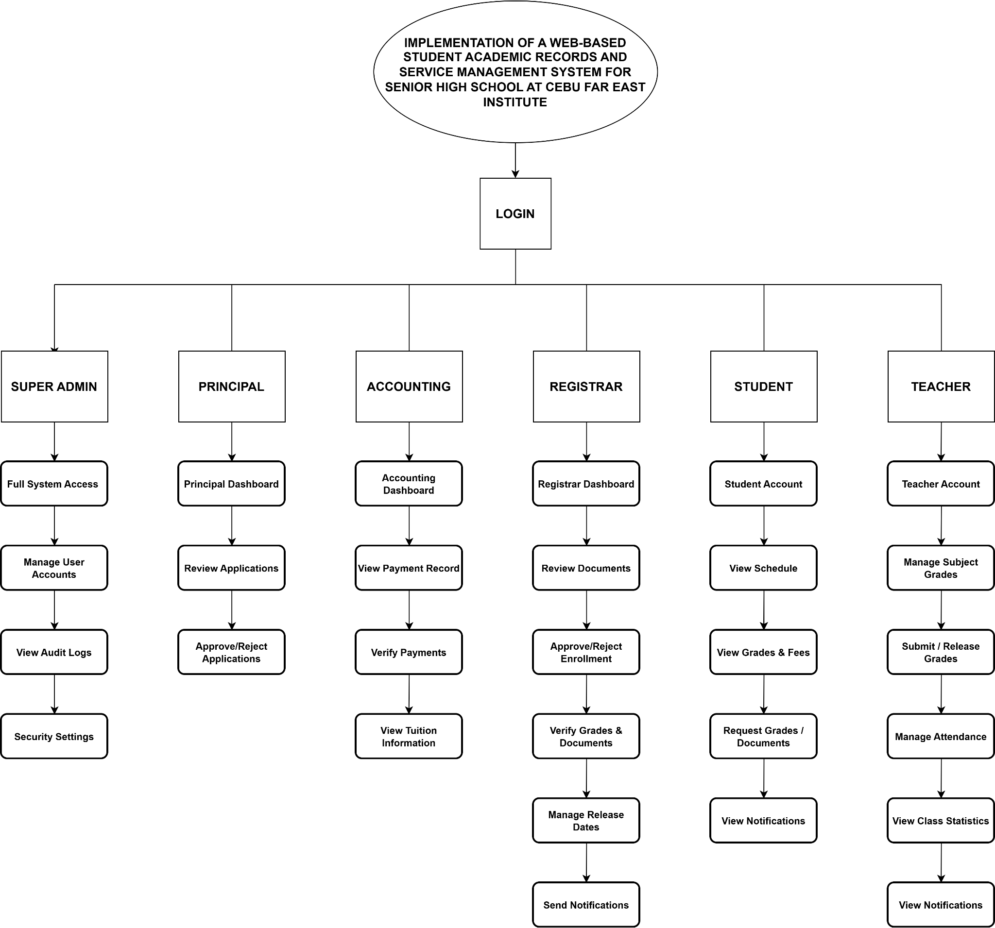

Work Breakdown Structure
Figure 2
Cost and Benefit Analysis
The integrity, security, and efficiency of an academic record management process are fundamental to upholding the institutional standards of any educational organization. The existing manual system, while functional, presents significant operational and institutional risks in the modern digital landscape. Its reliance on paper-based processes and manual data handling introduces vulnerabilities related to data accuracy, the potential for human error, and the lack of transparent and auditable records. From a legal and compliance standpoint, this manual system falls short of contemporary standards for data privacy and security, creating an imperative for modernization to mitigate risks and ensure institutional accountability.
In response to these challenges, the development of INFORM, a Web-Based Student Academic Records and Service Management System, was undertaken as a strategic initiative. This project was not merely a technological upgrade but also a necessary investment in institutional integrity. The new platform is designed to enhance security through role-based authentication for Students, Teachers, Registrars, Principals, and the Accounting Office; ensure data accuracy through automated grade encoding and attendance tracking; and provide a fully auditable trail for all academic transactions through the Grade Request Pipeline (Student → Teacher → Registrar → Principal → Teacher → Student), thereby aligning with best practices in digital governance. The transition to this platform required a one-time capital expenditure to cover the development, testing, and deployment of a secure, scalable, and user-friendly system.
The following financial analysis provides a transparent and comprehensive breakdown of the costs and benefits associated with this transition. It is presented in three parts. Table 1 details the recurring operational costs of the outdated manual system, establishing a financial baseline. Table 2 outlines the one-time development costs required to build the new platform. Finally, Table 3 presents the new annual operating costs of the automated system. This analysis serves as the foundation for the subsequent Return on Investment (ROI) evaluation, which articulates the long-term financial implications and strategic value of this critical project.
Table 1: Existing Annual Cost (Manual System)
Position/ Expense | Monthly Cost (₱) | Annual Cost (₱)
Bond Paper | 500.00 | 6,000.00
Printer Ink | 800.00 | 9,600.00
Photocopying | 400.00 | 4,800.00
Electricity | 1,500.00 | 18,000.00
Microsoft Office / Google Sheets Subscription | 250.00 | 3,000.00
Total Cost | ₱3,450.00 | ₱41,400.00
The total monthly expense for the existing manual system is ₱3,450.00, leading to an annual cost of ₱41,400.00. These costs are primarily driven by recurring needs such as bond paper, printer ink, photocopying, electricity, and software subscriptions for manual data entry. This figure represents the financial baseline required to maintain the old, labor intensive process and serves as the benchmark for evaluating the new system's financial impact.
Table 2: New System Development Cost (One-Time Investment)
Position/ Expense | Monthly Cost (₱) | Total Cost (₱)
Developer Salary (2 Developers) | 37,500.00 | 225,000.00
Vercel (Frontend Hosting) | 1,225.00 | 7,350.00
Railway (Backend Hosting) | 1,225.00 | 7,350.00
Quality Assurance & Testing | 1,500.00 | 9,000.00
Development Tools & Licenses | 1,200.00 | 7,200.00
Bond Paper for Printing | 50.00 | 300.00
Total Development Cost | 42,700.00 | 256,200.00
The total one-time investment required to develop the new automated system over a six-month period is ₱256,200.00. The majority of this cost, ₱225,000.00, is allocated to developer salaries, reflecting the skilled labor needed to build, test, and deploy the software. The remaining expenses cover frontend hosting on Vercel, backend hosting on Railway, development tools such as Visual Studio Code, GitHub and Postman, as well as testing during the development phase. This figure represents the total capital expenditure needed to transition the Implementation of a Web-Based Student Academic Records and Service Management System for Senior High School at Cebu Far East Institute from a manual to a fully automated platform.

Table 3: Annual Operating System (New System)
Position/ Expense | Monthly Cost (₱) | Annual Cost (₱)
Developer Salary | 37,500.00 | 450,000.00
Vercel (Frontend) | 1,225.00 | 14,700.00
Railway (Backend) | 1,225.00 | 14,700.00
Quality Assurance & Testing | 1,500.00 | 18,000.00
Development Tools & Licenses | 1,200.00 | 14,400.00
Bond Paper for Printing | 50.00 | 600.00
Total Annual Operating Cost | 42,700.00 | 512,400.00
Return on Investment (ROI) Analysis
The transition from the existing manual record management system to the new automated platform involves a shift in cost structure. The previous manual process incurred an annual cost of ₱41,400.00 (Table 1), while the new automated system has a recurring annual operating cost of ₱512,400.00 (Table 3).
The Return on Investment (ROI) is calculated to determine the financial gain or loss relative to the cost. The formula is:
ROI = (Net Profit from Investment / Cost of Investment) x 100
First, the net profit (or loss) from the investment is determined by calculating the annual savings:
Annual Savings = Old System Annual Cost - New System Annual Cost
Annual Savings = ₱41,400.00 − ₱512,400.00 = −₱471,000.00
This results in an increased annual expenditure of ₱471,000.00. Because the annual savings are negative, the initial one-time development cost of ₱256,200.00 is not recovered through operational savings.
Based on this financial structure, the project represents a strategic investment in modernization and institutional efficiency rather than immediate operational cost savings. The value is realized through improved accuracy of academic records, faster processing of enrollment and grade requests, enhanced data security through role-based authentication, and a fully auditable system across all six user roles Student, Teacher, Registrar, Principal, Accounting, and Admin justifying the increased annual expenditure.

MoScoW
IMPLEMENTATION OF A WEB-BASED STUDENT ACADEMIC RECORDS AND SERVICE MANAGEMENT SYSTEM FOR SENIOR HIGH SCHOOL AT CEBU FAR EAST INSTITUTE

Must Have:
- Role-Based Authentication and Login
- Student Enrollment Module
- Grade Encoding for Teacher
- Grade Request Pipeline
- Attendance Recording
- Student Dashboard
- Document Request Module
- Tuition Fee Viewing
- Admin Dashboard
- Accounting Dashboard
- Notification Module
- Principal Portal

Should Have:
- JOBERT AI Assistant
- Teacher Time Log Module
- Forgot Password Module
- Grade Deadline Locking
- Grade Request Progress Tracker
- Search Students

Could Have:
- Dark Mode / Theme Toggle
- Grade Color Legend
- Downloadable Documents
- Class Summary Statistics
- Recent Activity Feed
- Mobile Responsive Sidebar

Won’t Have:
- Online Payment Integration
- Real-Time Email Notifications
- SMS Notifications
- Parent Portal
- Automated Report Card Generation
- Multi-School Support
- Biometric Time Log Integration

Gantt Chart
Figure 3

Critical Path
Figure 4
Data and Process Modeling
The Implementation of a Web-Based Student Academic Records and Service Management System for Senior High School at Cebu Far East Institute is an integrated data and process management system developed for Cebu Far East Institute. It uses a relational MySQL database to manage important information related to students, teachers, administrators, subjects, enrollments, grades, attendance, payments, document requests, schedules, notifications, system configurations, audit records, and workflow activities. The students, teachers, and admins tables store user and account information, while the subjects table manages academic offerings and teacher assignments. Enrollment records are connected to selected subjects through the enrollment subjects table, representing the many to many relationship between enrollments and subjects. The grades and attendance tables record students academic performance and attendance for each subject and term, while the payments and documents tables manage financial transactions and school document requests. Supporting tables such as notifications, staff notifications, audit log, enrollment config, grade request config, and schedule provide communication, monitoring, term control, scheduling, and accountability. Data integrity is maintained through primary keys, unique identifiers, foreign keys, composite keys, controlled status values, and validation rules that help prevent duplicate or invalid records.
The process modeling follows a role-based and sequential workflow that begins with authentication. Students, teachers, registrars, principals, accounting personnel, and administrators submit their credentials and are directed to their appropriate dashboards after successful verification. Students may access their profiles, grades, attendance, schedules, payment information, documents, and notifications, while teachers manage grades and attendance. Administrative personnel review enrollment applications, verify payments, process document requests, and approve academic requests. The enrollment process begins when an applicant submits an application, which is reviewed by the registrar and forwarded to the principal for final approval or rejection. Approved applicants receive a generated student ID and temporary password through email, while rejected applications are stored with the reason for rejection and a corresponding notification.
The grade request process is controlled by the active term configuration and moves from student submission to teacher calculation, registrar review, principal approval, grade release, and student notification. Payment transactions remain pending until verified by accounting or an authorized administrator, while document requests proceed from submission to approval or rejection before the student is notified. Throughout these processes, the Express backend validates requests, enforces role-based access control, updates the appropriate database records, and generates notifications and audit information. Overall, the data and process model provides a structured, secure, and traceable framework for managing student records and delivering academic and administrative services through the RMS platform.

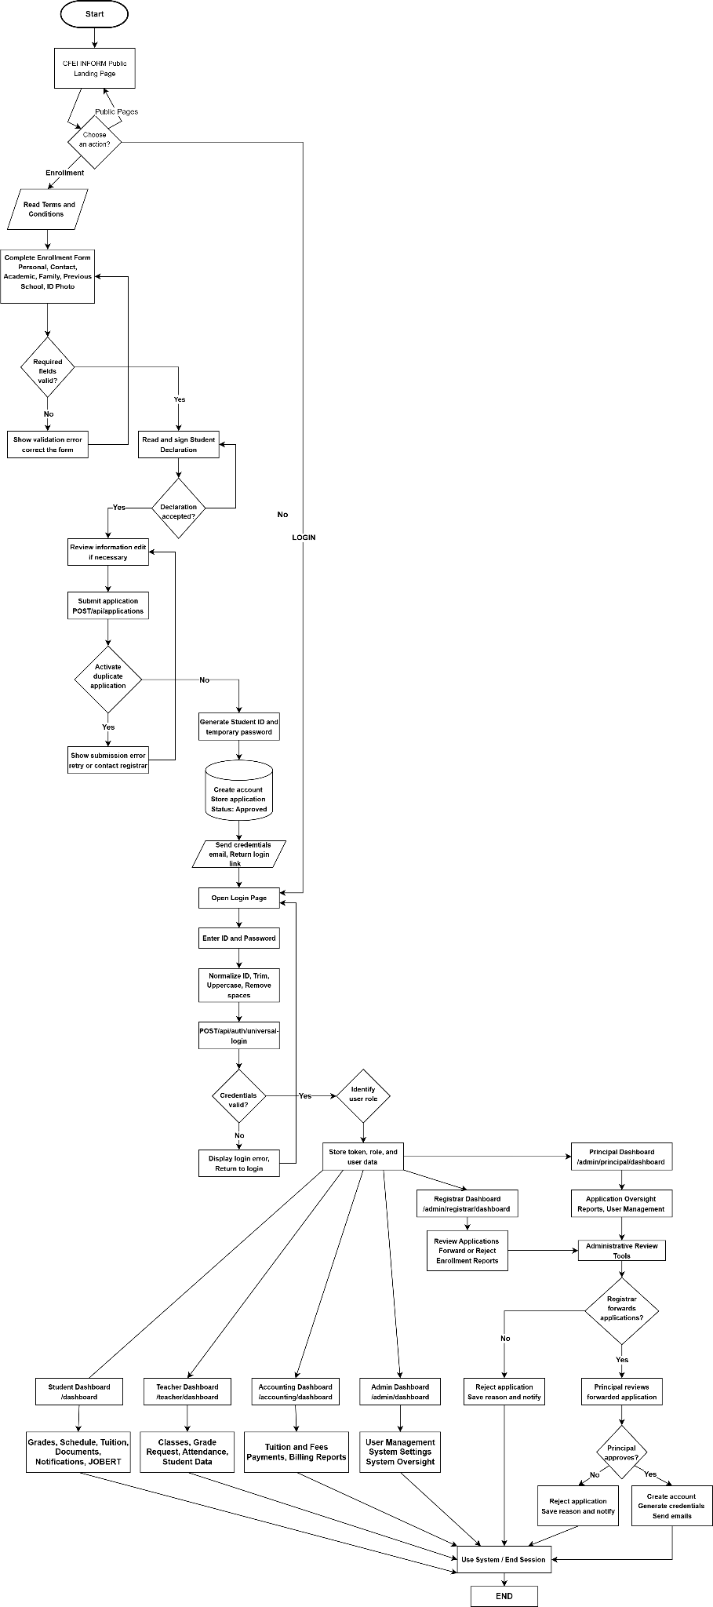
Existing Flow Chart
Figure 5
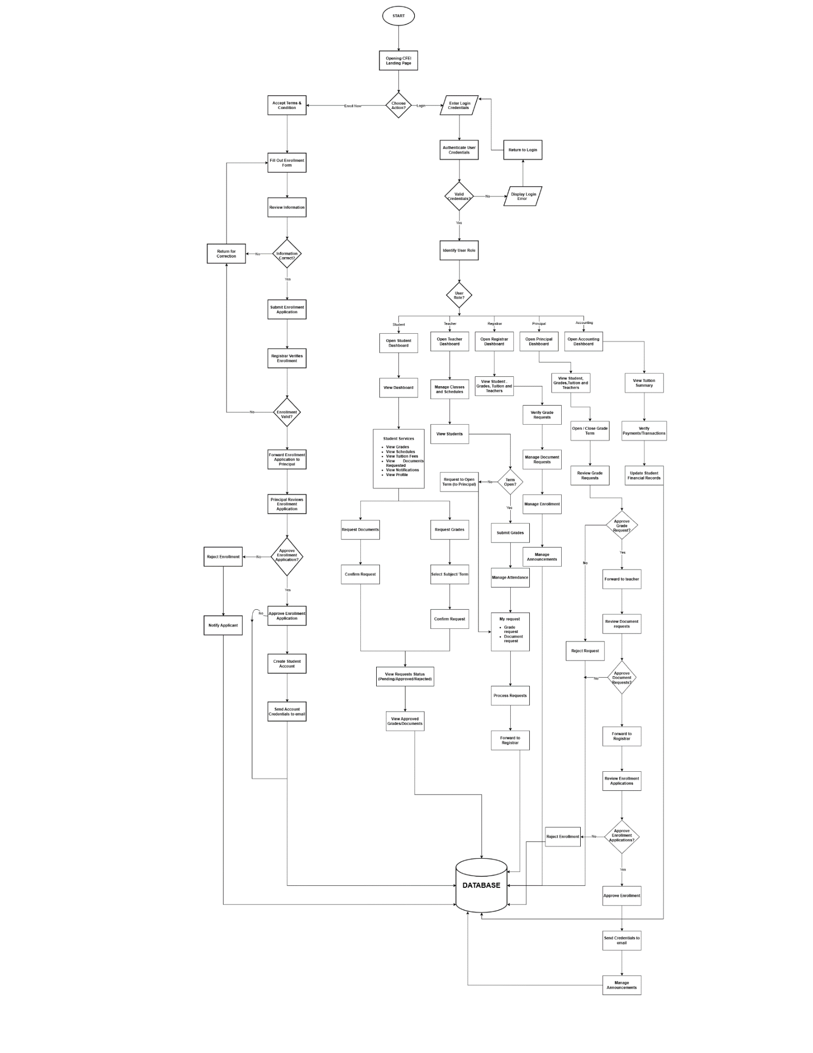
Proposed Flowchart
Figure 6
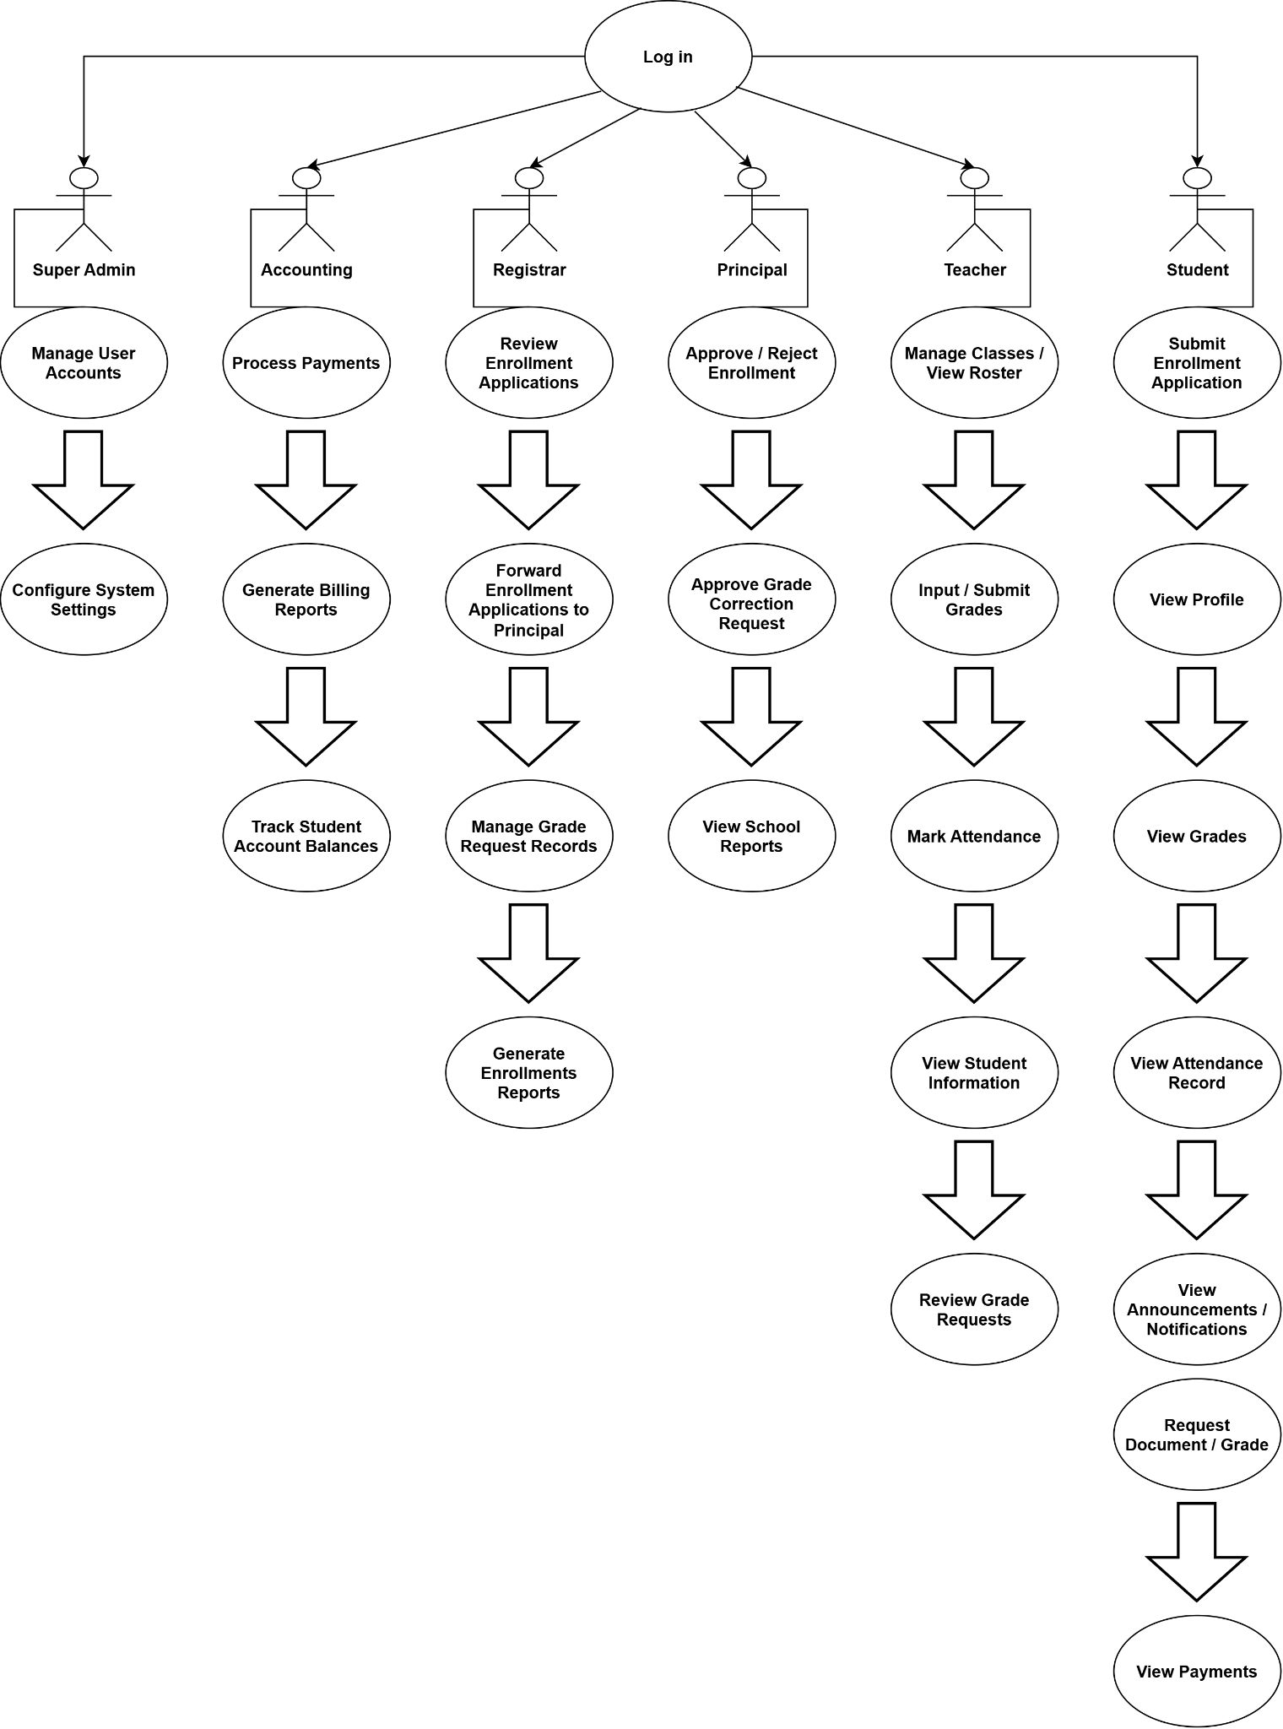
Use Case Diagram
Figure 7
Narrative
Table 1: Login Use Case
Field | Details
Use Case | Login
Summary | Students, teachers and authorized administrators can log in to access the RMS according to their assigned role.
Actors | Students, Teachers, Principal, Registrar, Accounting, General Administrator
Purpose | To provide secure access to the appropriate RMS dashboard.
Pre-condition | The user has a registered account and is viewing the login page.
Post-condition | The credentials are authenticated and the user is redirected to role-based dashboard.
Exception | Blank fields, invalid credentials, invalid student ID format, or temporary student account lockout.

Flow of Events
Actor Response | System Response
- Visit Website | - Display Website
- Click Login | - Display Login Form
- Enter User ID and Password | - Validate credentials and identify the user role.
- Submit Login Form | - Successful login and redirect to the correct dashboard
Alternative Flow
Actor Response | System Response
5.1 Leave User ID or Password blank | 5.2 Error: Required fields cannot be empty.
5.3 Enter an invalid ID or password | 5.4 Error: Invalid ID or password.
5.5 Exceed the failed-login limit | 5.6 Error: Student account is locked temporarily.

Table 2: Submit Enrollment Application Use Case
Field | Details
Use Case | Submit Enrollment Application
Summary | Applicants complete and submit the enrollment form with personal, academic, contact, and learning information.
Actors | Student / Applicant
Purpose | To record an applicant’s enrollment information and create an applicant or student record.
Pre-condition | The applicant can access the enrollment page and has the required information.
Post-condition | The application is saved. In the current backend, a Student ID and temporary password are generated and the application is immediately marked approved.
Exception | Missing required fields, duplicate active email application, or failure to generate a unique Student ID.

Flow of Events
Actor Response | System Response
- Visit Enrollment Page | - Display Terms and Conditions
- Accept Terms and Conditions | - Display Enrollment Form
- Enter applicant details | - Validate and retain the entered information
- Review the information | - Display Review and Confirm step
- Click Submit Application | - Save application, generate credentials, and display the success message
Alternative Flow
Actor Response | System Response
5.1 Leave a required field blank | 5.2 Error: Please complete the required field.
9.1 Use an email with an active application | 9.2 Error: An application with this email is already pending.
9.3 Student ID generation fails | 9.4 Error: Could not generate a unique Student ID.

Table 3: Request Grade Use Case
Field | Details
Use Case | Submit Grade Request
Summary | Student request a grade for a subject during an open grade request period.
Actors | Student
Purpose | To initiate the controlled grade request workflow.
Pre-condition | The student is logged in, the subject exists, and the request window is open for the selected term.
Post-condition | A request is saved as student requested and the assigned teacher is notified.
Exception | Invalid term, closed request window, unknown subject, or duplicate pending request.

Flow of Events
Actor Response | System Response
- Open My Grades | - Display subjects, terms, and request states
- Select a term | - Check whether grade requests are open
- Select a subject | - Check the subject and duplicate request status
- Click Request Grade | - Save the request and notify the assigned teacher
- Return to My Grades | - Display the request as pending
Alternative Flow
Actor Response | System Response
3.1 Select an invalid term | 3.2 Error: Select Term 1, Term 2, or Term 3.
4.1 Request while the window is closed | 4.2 Error: Grade requests are currently closed.
6.1 Submit a duplicate active request | 6.2 Error: A pending request already exists for this subject and term.

Table 4: Process Grade Request Use Case
Field | Details
Use Case | Process and Release Grade Request
Summary | Teachers submit grades for review, authorized administrators forward them to the Principal, and approved grades are returned to the teacher for release.
Actors | Teacher, Registrar, Principal
Purpose | To verify and authorize grade information before it is released to the student.
Pre-condition | A student has submitted a grade request and the appropriate staff member is authenticated.
Post-condition | The request is approved through the workflow and marked released to student after teacher release; the student is notified.
Exception | Invalid score, incorrect workflow stage, missing rejection reason, or request not found.

Flow of Events
Actor Response | System Response
- Teacher opens Grade Requests | - Display assigned student requests
- Enter score and remarks | - Validate score from 0 to 100
- Submit grade to Registrar | - Set status to Registrar Review and notify Registrar
- Registrar sends request to Principal | - Set status to Principal Review and notify Principal
- Principal approves request | - Set status to Principal Approved and notify Registrar
- Registrar releases to Teacher | - Set status to Registrar Released and notify Teacher
- Teacher releases grade | - Set status to Released to Student and notify the student
Alternative Flow
Actor Response | System Response
3.1 Enter a score below 0 or above 100 | 3.2 Error: Score must be between 0 and 100.
7.1 Send a request in the wrong status | 7.2 Error: Request is not in the Registrar review stage.
9.1 Principal returns the grade | 9.2 Return request to Teacher for correction and record the reason.
13.1 Release before Registrar approval | 13.2 Error: Request is not ready for teacher release.

Table 5: Request Document Use Case
Field | Details
Use Case | Request Student Document
Summary | Students request a supported official document by selecting the document type, purpose, and number of copies.
Actors | Student
Purpose | To submit an official document request through the student portal.
Pre-condition | The student is logged in and supported document types are available.
Post-condition | The document request is saved as pending with a reference number.
Exception | Invalid document type, missing or invalid purpose, invalid copies, or duplicate pending request.

Flow of Events
Actor Response | System Response
- Open Documents | - Display available document types and request history
- Select a document type | - Display the document-request form
- Enter purpose and number of copies | - Validate the request information
- Confirm the request | - Save the request as pending and display its reference number
Alternative Flow
Actor Response | System Response
3.1 Select an unsupported document type | 3.2 Error: Invalid document type.
5.1 Leave the purpose blank | 5.2 Error: A valid purpose is required.
7.1 Submit a duplicate pending request | 7.2 Error: A pending request already exists.

Table 6: Submit Payment Use Case
Field | Details
Use Case | Submit Student Payment
Summary | Students record a payment for a tuition or fee item for verification by authorized staff.
Actors | Student
Purpose | To maintain a digital record of payment submissions and their verification status.
Pre-condition | The student is logged in and has a valid fee item and payment amount.
Post-condition | The payment is saved as pending and the student is notified that it is awaiting verification.
Exception | Missing fee item, invalid amount, expired session, or unsuccessful save operation.

Flow of Events
Actor Response | System Response
- Open Tuition Fee or Payments | - Display fee summary and payment history
- Select fee item and enter amount | - Validate the fee item and amount
- Submit payment | - Save the payment as pending and notify the student
- Reopen payment history | - Display the submitted payment and its status
Alternative Flow
Actor Response | System Response
3.1 Leave the fee item blank | 3.2 Error: Fee item is required.
3.2 Enter an invalid amount | 3.3 Error: Enter a valid payment amount.
5.1 Submit after the session expires | 5.2 Error: Please log in again.

Table 7: View Academic Information Use Case
Field | Details
Use Case | View Academic and Student Services Information
Summary | Students view their grades, class schedule, tuition and fees, document status, and dashboard summaries.
Actors | Student
Purpose | To provide students with self-service access to their academic and administrative information.
Pre-condition | The student has successfully logged in.
Post-condition | The selected information is displayed. Some dashboard panels may show mock or fallback data when server data is unavailable.
Exception | Expired session, unavailable record, no data for the selected term, or unavailable backend data.

Flow of Events
Actor Response | System Response
- Log in to the Student Portal | - Display dashboard summaries and quick-access options
- Select My Grades and a term | - Display available grades and grade-request states
- Select My Schedule | - Display the student schedule
- Select Tuition Fee or Documents | - Display fee, payment, document, and request information
Alternative Flow
Actor Response | System Response
3.1 Select a term with no released grade | 3.2 Display a not-available or pending state.
5.1 Select a day with no class | 5.2 Display an empty schedule state.

Table 8: Process Enrollment Application Use Case
Field | Details
Use Case | Review and Process Enrollment Application
Summary | Authorized administrators review enrollment applications and may forward, approve, or reject them.
Actors | Registrar, Principal, General Administrator
Purpose | To review applicant information and record an enrollment decision.
Pre-condition | The staff member is authenticated and an application exists in a reviewable state.
Post-condition | The application is forwarded to Principal review, approved, or rejected with a recorded reason.
Exception | Application not found, incorrect status, missing rejection reason, or duplicate processing.

Flow of Events
Actor Response | System Response
- Log in to the administration dashboard | - Display enrollment applications
- Select an application | - Display applicant and enrollment details
- Review the application | - Display Forward, Approve, and Reject options according to the current status
- Forward the application | - Change status to Principal Review and record the Registrar review
- Principal approves or rejects the application | - Update the status and record the decision; approved review applications receive generated credentials
Alternative Flow
Actor Response | System Response
5.1 Select an application that was already processed | 5.2 Error: Application has already been processed.
7.1 Forward an application in the wrong status | 7.2 Error: Application is not in a forwardable state.
9.1 Reject without a reason | 9.2 Error: Rejection reason is required.

Table 9: Verify Payment Use Case
Field | Details
Use Case | Verify Student Payment
Summary | Authorized staff review pending student payments and mark valid payments as verified.
Actors | Accounting Staff, General Administrator
Purpose | To confirm payment submissions and update the student payment history.
Pre-condition | The staff member is authenticated and the payment is pending.
Post-condition | The payment is verified, an audit action is recorded, and the student is notified.
Exception | Payment not found, payment already processed, or unauthorized access.

Flow of Events
Actor Response | System Response
- Open the Administration or Accounting Dashboard | - Display pending payments
- Select a payment | - Display student, fee item, amount, and payment status
- Click Verify Payment | - Mark the payment as verified and record the reviewer
- Student opens Payments | - Display the verified payment and notification
Alternative Flow
Actor Response | System Response
3.1 Select a payment that does not exist | 3.2 Error: Payment not found.
3.2 Select a payment that was already processed | 3.3 Error: This request has already been processed.

Table 10: Request Document Use Case
Field | Details
Use Case | Request Student Document
Summary | Students request supported official documents by entering the document type, purpose, and number of copies.
Actors | Student
Purpose | To submit an official document request through the student portal.
Pre-condition | The student is logged in and supported document types are available.
Post-condition | A pending document request with a reference number is saved.
Exception | Invalid document type, invalid purpose, invalid number of copies, or duplicate pending request.

Flow of Events
Actor Response | System Response
- Open Documents | - Display document types and request history
- Select a document type | - Display the request form
- Enter purpose and copies | - Validate the request information
- Confirm the request | - Save the request as pending and display its reference number
Alternative Flow
Actor Response | System Response
3.1 Select an unsupported document type | 3.2 Error: Invalid document type.
5.1 Leave the purpose blank | 5.2 Error: A valid purpose is required.
7.1 Submit a duplicate pending request | 7.2 Error: A pending request already exists.

Table 11: Process Document Use Case
Field | Details
Use Case | Approve or Reject Document Request
Summary | Authorized administrators process pending student document requests by approving them with a release date or rejecting them with a reason.
Actors | Registrar, General Administrator
Purpose | To control document approval and inform the student of the result.
Pre-condition | The staff member is authenticated and the document request is pending.
Post-condition | The request is approved with an expected release date or rejected with a stored reason.
Exception | Request not found, request already processed, missing release date, or invalid rejection reason.

Flow of Events
Actor Response | System Response
- Open pending Documents in the admin dashboard | - Display pending document requests
- Display pending document requests | - Display the student and request details
- Approve and enter expected release date | - Mark the request approved and notify the student
- Or select Reject and enter a reason | - Mark the request rejected and notify the student
Alternative Flow
Actor Response | System Response
5.1 Approve without a release date | 5.2 Error: Expected release date is required.
7.1 Reject without a valid reason | 7.2 Error: Rejection reason must be between 10 and 500 characters.
3.1 Select a processed request | 3.2 Error: This request has already been processed.

Table 12: Record Attendance Use Case
Field | Details
Use Case | Record and Monitor Attendance
Summary | Teachers view attendance for an assigned subject, update attendance records, and view class attendance statistics.
Actors | Teacher
Purpose | To maintain attendance information for students in a subject.
Pre-condition | The teacher is authenticated and has access to the selected subject.
Post-condition | Attendance data is updated and class attendance information can be reviewed.
Exception | Unauthorized subject, invalid attendance data, or unavailable class record.

Flow of Events
Actor Response | System Response
- Open the Teacher Dashboard | - Display assigned subjects and attendance options
- Select a subject | - Display student attendance records
- Mark or update attendance | - Validate and save the attendance data
- Open class attendance statistics | - Display the attendance summary
Alternative Flow
Actor Response | System Response
3.1 Select a subject outside the teacher’s access | 3.2 Error: Access to this subject is not authorized.
5.1 Submit incomplete attendance data | 5.2 Error: Attendance data is invalid.
7.1 Request unavailable class statistics | 7.2 Display an unavailable-data message.

Table 13: Manage Grade Request Period Use Case
Field | Details
Use Case | Open or Close Grade Requests
Summary | The Principal opens or closes the grade-request period for Term 1, Term 2, or Term 3.
Actors | Principal
Purpose | To control when students can submit grade requests.
Pre-condition | The Principal is authenticated with administrator privileges.
Post-condition | The selected term is marked open or closed; opening the period notifies enrolled students.
Exception | Invalid term, unauthorized user, or configuration update failure.

Flow of Events
Actor Response | System Response
- Open Grade Request Configuration | - Display the status for Term 1, Term 2, and Term 3
- Select a term | - Display Open and Close controls
- Click Open Requests | - Mark the term open and notify enrolled students
- Click Close Requests | - Mark the term closed and record the closing information
Alternative Flow
Actor Response | System Response
3.1 Enter an invalid term | 3.2 Error: Select Term 1, Term 2, or Term 3.
5.1 Use the function without administrator access | 5.2 Error: Authentication or authorization failed.

Table 14: Manage Notifications Use Case
Field | Details
Use Case | View and Manage Notifications
Summary | Students and staff view workflow notifications and mark them as read.
Actors | Student, Teacher, Registrar, Principal, General Administrator
Purpose | To inform users about enrollment, grade, document, payment, and system events.
Pre-condition | The user is authenticated for the appropriate notification service.
Post-condition | Notifications are displayed and selected notifications can be marked as read.
Exception | Empty notification list, expired session, or notification service failure.

Flow of Events
Actor Response | System Response
- Open Notifications | - Display unread and read notifications
- Select a notification | - Display the notification details
- Click Mark as Read | - Update the notification status
- Refresh the notification list | - Display the updated read/unread sections
Alternative Flow
Actor Response | System Response
1.1 Open Notifications with no records | 1.2 Display an empty-notifications message.
5.1 Mark a notification without a valid session | 5.2 Error: Please authenticate again.

Table 15: View Profile Use Case
Field | Details
Use case | View User Profile
Summary | A logged-in user views the profile information associated with the authenticated account.
Actors | Student, Teacher, Administrator
Purpose | To display the user identity and account information used by the RMS.
Pre-condition | The user has logged in successfully.
Post-condition | The system displays the authenticated user’s profile information.
Exception | Expired session, user record not found, or unauthorized profile request.

Flow of Events
Actor Response | System Response
- Open Profile | - Request the authenticated user information
- Wait for the profile to load | - Display the name, ID, role, and available account details
- Return to the dashboard | - Preserve the authenticated session
Alternative Flow
Actor Response | System Response
1.1 Open Profile after the session expires | 1.2 Error: Please log in again.
2.1 The account cannot be found | 2.2 Error: User or student record not found.

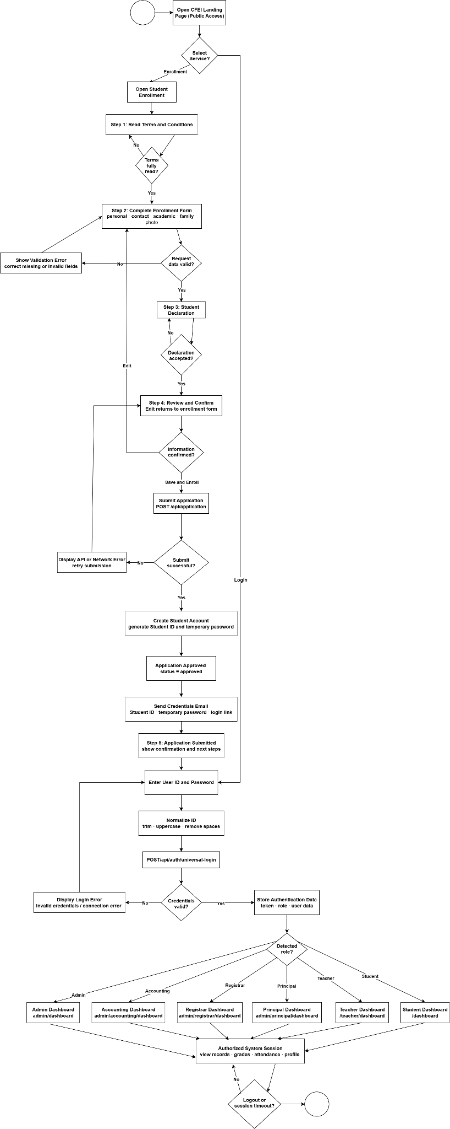
State Chart Diagram
Figure 9

Entity Relationship Diagram
Figure 10
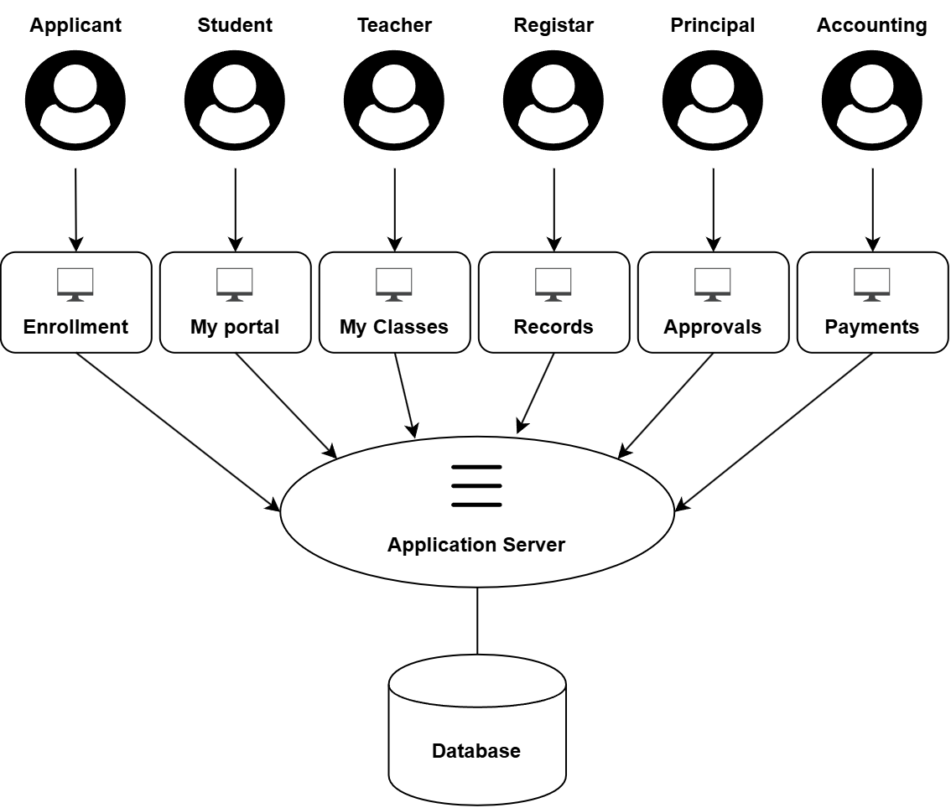

System Architecture
Figure 11
User Side
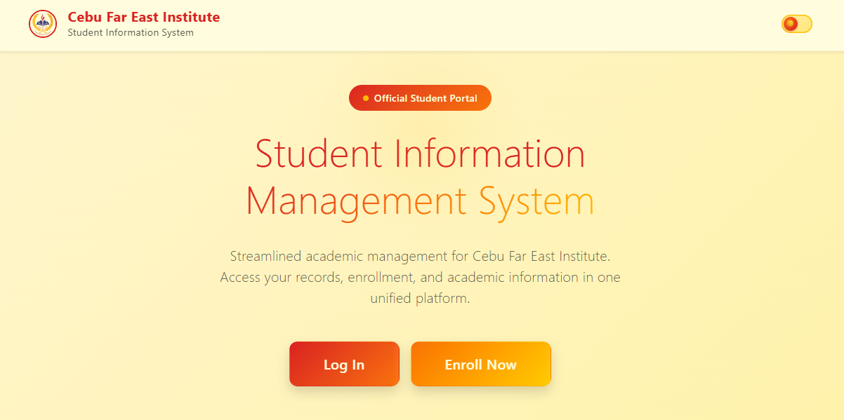
User - Landing Page | Figure 12
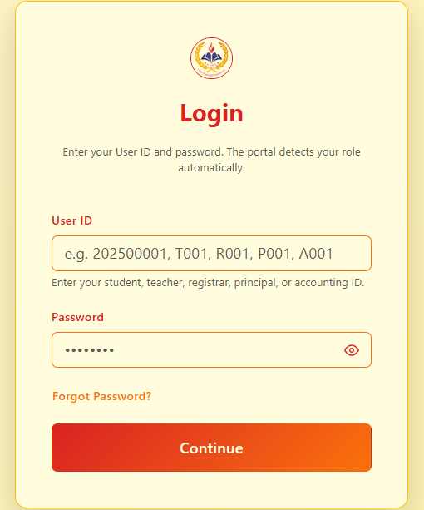
User - Log in | Figure 13
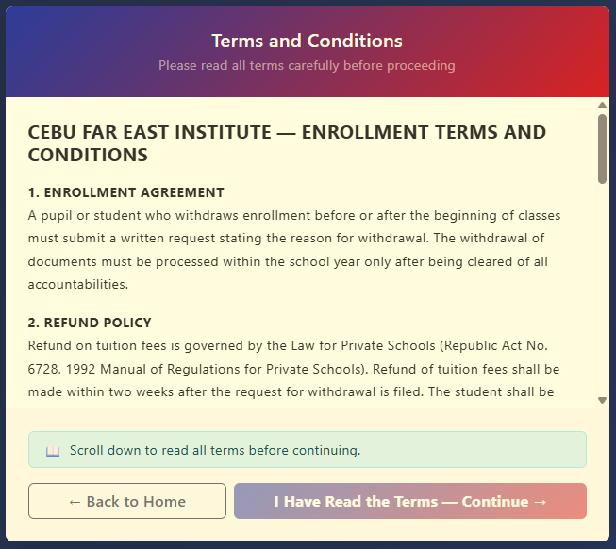
User – Terms & Conditions | Figure 14

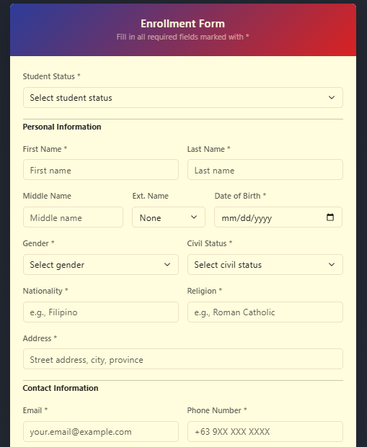
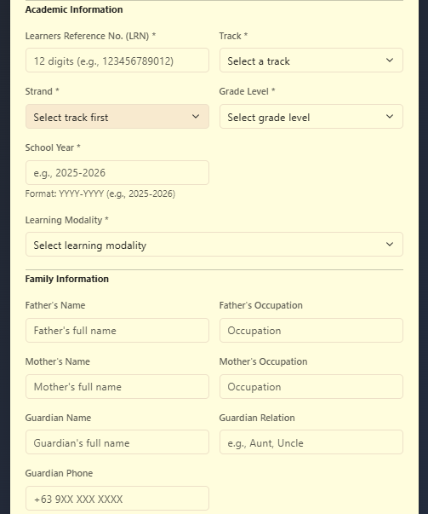
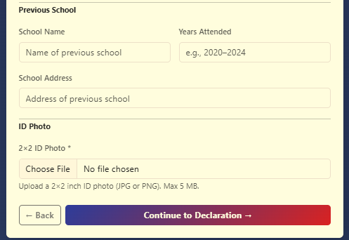
User – Enrollment Form | Figure 15
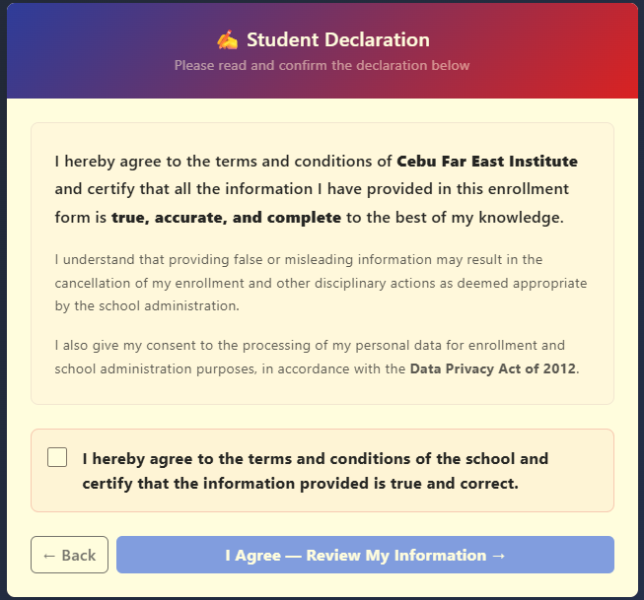
User – Student Declaration | Figure 16

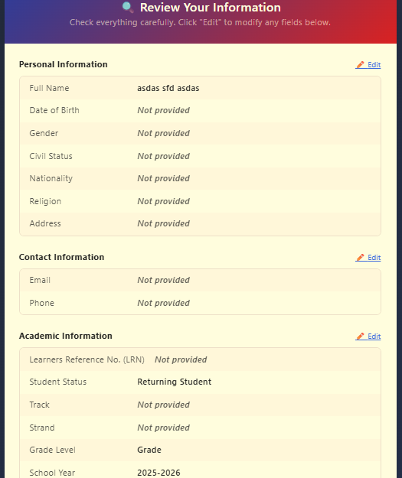
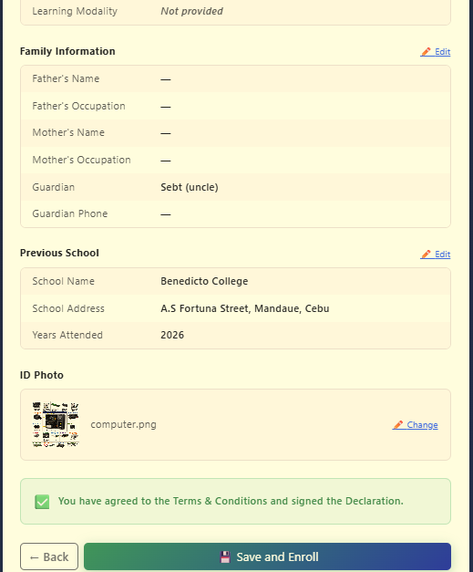
User – Review Information | Figure 17

Security Implementation
The Implementation of a Web-Based SHS Record Management System at CFEI includes security measures to protect student, teacher, and administrative records from unauthorized access and changes. Security is applied through user authentication, password protection, access control, session management, input validation, database protection, and controlled access to system resources.
Authentication. The system uses JSON Web Tokens (JWT) to authenticate registered users. Students, teachers, and administrators have separate login processes. When a user submits their credentials, the system verifies them against the corresponding database record. If the credentials are valid, the system generates a JWT containing the user's identification and role. Student sessions expire after 24 hours, while teacher and administrator sessions expire after 8 hours. The token can be sent through a protected HTTP-only cookie or through the Authorization header using the Bearer token format.
Password Protection. User passwords are not stored directly in the database. The system uses the bcrypt.js library to hash passwords before they are saved in MySQL. During login, the submitted password is compared with the stored hash using bcrypt verification. This prevents the actual password from being stored as readable text in the database.
Account Lockout. The student login process limits repeated failed login attempts. After five unsuccessful attempts, the student's account is temporarily locked for 15 minutes. The failed-attempt count is reset after a successful login. This limits repeated attempts to guess a student's password.
Role-Based Access Control. The system restricts access to protected resources based on the user's role. Student routes require student authentication, teacher routes require teacher authentication, and administrator routes require administrator authentication. The authentication middleware verifies the JWT before allowing access to protected API resources. This prevents users from accessing system functions that are not available to their assigned role.
Session and Cookie Security. Authentication tokens can be stored in HTTP-only cookies so that they cannot be accessed directly by client-side JavaScript. The cookies use the SameSite=Strict setting to limit cross-site requests, while the Secure setting is enabled when the system is running in a production environment. These settings help protect authenticated sessions.
Input Validation. Information submitted by users is checked before it is processed by the backend. The system validates required enrollment fields and checks values such as student identification numbers, grades, payment amounts, document types, number of copies, terms, and rejection reasons. Grade percentages, for example, are limited to values from 0 to 100. Document requests are also checked to make sure that the selected document type and other required information are valid. Backend validation is used so that invalid information cannot be submitted by bypassing the frontend.
SQL Injection Protection. Database queries use parameterized statements through the MySQL2 library. User-provided values are passed separately from the SQL statements using placeholders such as ?. This prevents user input from being directly combined with SQL commands and helps protect the database from SQL injection.
Cross-Origin Request Protection. The Express backend uses CORS configuration to control which client origins can communicate with the API. The allowed origins are configured through environment variables, and the permitted methods and credentials are controlled by the backend. This limits requests from unauthorized web origins.
Database Integrity and Transactions. MySQL constraints and transactions are used to maintain the consistency of stored records. Primary keys, foreign keys, unique constraints, and status values are used to maintain relationships between records. Enrollment creation and subject assignment are processed within a database transaction. If an error occurs during the process, the transaction is rolled back to prevent incomplete enrollment records from being saved.
Audit Logging. Important administrative activities are recorded in the audit_log table. These activities include enrollment approval or rejection, payment verification, and document approval or rejection. The audit record includes the administrator's identification, the action performed, the target request, and the time of the action. This provides a record of important activities performed by administrators.
Environment and Credential Protection. Sensitive configuration values, such as database and email credentials, are managed through environment variables instead of being placed directly in the application source code. The project includes .env.example files that provide configuration templates without containing the actual credentials. This helps prevent sensitive information from being exposed through the source code repository.
Error Handling. The backend uses a centralized error-handling mechanism to process errors that occur during API requests. Authentication errors return controlled responses, such as invalid token, expired session, or authentication required, instead of exposing unnecessary application information to the user.
These security measures work together to protect the records and services managed by INFORM. Authentication controls who can access the system, role-based access controls what each user can access, password hashing protects stored passwords, validation checks submitted information, parameterized queries protect database operations, and audit logging records important administrative activities.

Development Methodology and Implementation
The development of INFORM followed a structured process that covered requirements gathering, system design, development, integration and testing, and documentation. These activities were carried out according to the needs of Cebu Far East Institute (CFEI) Senior High School. The system was developed as a centralized platform for managing student academic records and school services, with separate functions for students, teachers, and administrators.
Requirements Gathering. The development started by identifying the problems experienced by Senior High School students, teachers, and administrators in managing and accessing academic records and student services. The existing process required students to make manual inquiries and visit school offices to obtain information such as grades, schedules, study loads, tuition balances, and official documents. These processes also increased the workload of school personnel. The identified problems were used as the basis for determining the functions required in INFORM.
The system requirements were organized according to the three main user roles. Students were provided with functions for accessing grades, schedules, study loads, tuition information, announcements, and document requests. Teachers were provided with functions for managing grades and attendance and processing grade requests. Administrators were given functions for managing enrollment, student records, payments, documents, announcements, and other administrative activities.
System Design. After the requirements were identified, the system structure and database were designed. INFORM uses a client-server architecture in which the frontend communicates with the backend through a RESTful API. The backend handles requests from the frontend and communicates with the MySQL database to store and retrieve system records.
The database design includes records for students, teachers, administrators, subjects, enrollments, grades, attendance, payments, documents, notifications, schedules, enrollment applications, grade requests, and audit logs. Relationships between related records are maintained using database keys and constraints.
The system was also divided into separate modules. Authentication, students, enrollment, grades, attendance, payments, documents, notifications, teachers, administrators, and grade requests were organized into separate backend components. This modular structure allowed individual functions to be developed and tested without changing unrelated parts of the system.
System Development. The frontend was developed using Next.js, React, and TypeScript. These technologies were used to create the interfaces for students, teachers, and administrators. Bootstrap, Tailwind CSS, and custom CSS were used for the user interface. The system includes responsive layouts and light and dark themes.
The backend was developed using Node.js and Express.js. Express.js handles API routes, requests, responses, and middleware, while database access is handled directly through mysql2, a promise-based MySQL driver. Each model file builds parameterized SQL statements and executes them through a connection pool rather than through ORM, keeping query performance and SQL-injection protections explicit and auditable. The REST API provides communication between the frontend and backend using standard HTTP methods. Postman was also used for API development and testing.
MySQL was used as the relational database management system. It stores the records required by the different modules and supports the relationships between students, subjects, enrollment records, grades, attendance, payments, documents, and other system information.
Module Implementation. The student module was implemented to allow authenticated students to access their academic and service information. Students can view grades, attendance, schedules, tuition and payment records, document requests, and notifications. The enrollment function allows students to select available subjects and submit their enrollment. Enrollment records and selected subjects are processed using a database transaction so that incomplete records are not saved when an error occurs.
The enrollment application allows new students to submit their information through the system. The submitted information is validated, duplicate applications are checked, and a student identification number and temporary password are generated. The password is hashed before the student account is stored. The system sends generated credentials through email using Resend API.
The teacher module allows teachers to access assigned subjects and students, view grades and attendance, and submit student grades. Grade values are checked to make sure they remain within the allowed range of 0 to 100. Attendance information is also validated before it is stored.
The grade request module manages the processing of grade requests. The workflow records each request according to its current status and allows the request to move through the required stages, including student submission, teacher processing, administrative review, approval, and final release to the student. Staff notifications are used to inform personnel when a request requires action or when its status changes.
The administrative module allows authorized administrators to manage and monitor system activities. Administrators can process enrollment requests, verify payments, process document requests, view student and teacher records, and review audit records. Important administrative actions are recorded with the administrator's identification and timestamp.
The payment module allows students to view payment records and submit payment information for verification. Payments are initially recorded as pending and can be verified by an authorized administrator. The system also provides a payment summary showing the assessment, verified payments, and remaining balance.
The document module allows students to request school documents such as Transcript of Records, Certificate of Enrollment, Good Moral Certificate, Diploma, and Form 137. The system validates the document type, purpose, and number of copies and checks for duplicate pending requests. Each request receives a reference number and status, while administrators can approve or reject the request and assign an expected release date.

Integration and Testing. After the individual modules were developed, they were connected through the frontend, backend, REST API, and database. Each module was tested separately before being integrated with the other system components. The modular structure made it possible to identify and correct errors within individual features during development.

API requests were tested during backend development to verify that the frontend could communicate correctly with the server. Database operations were also checked to ensure that records were created, retrieved, updated, and maintained correctly. Authentication and role restrictions were tested to make sure that students, teachers, and administrators could access only the functions assigned to their roles.
The integration process also covered the grade request workflow, enrollment, payments, document requests, notifications, and administrative activities. These functions were tested as connected processes rather than as isolated features.

Security Implementation. Security was included during the development and integration of the system. INFORM uses JSON Web Tokens (JWT) for authentication and bcrypt.js for password protection. Access to system functions is restricted according to user roles. The system also uses protected API routes and database controls to protect student and administrative information.
Administrative activities are recorded in an audit log to provide a record of important actions. The system also follows the Data Privacy Act of 2012 (Republic Act No. 10173) in handling student personal and academic information.

System Implementation. The completed implementation connects the frontend, backend, MySQL database, authentication, and supporting services into one system. Students can access their academic records and school services, teachers can manage grades and attendance, and administrators can manage and monitor student-related transactions.
The system uses Next.js, React, TypeScript, Node.js, Express.js, and MySQL as its main technologies. The REST API connects the frontend and backend, while the database stores the records used by the system.
The implementation provides a centralized way of accessing and managing student information. Instead of relying only on repeated manual inquiries, students can use the system to access available academic and school service information. School personnel can also manage records and process requests through their respective system functions.
Documentation. The final stage of development involved documenting the completed system, its functions, technologies, and implementation. The development process was completed within the academic capstone schedule through the phases of requirements gathering, system design, development, integration and testing, and documentation.
The documentation records the system structure, technologies, modules, security measures, and major processes used in INFORM. This provides a reference for understanding how the system was developed and how its functions are connected.

Chapter 5
Summary, Conclusion, and Recommendations
Summary
The system was developed using Next.js, React, TypeScript, Node.js, Express.js, and MySQL. It follows a client-server architecture, where the frontend communicates with the backend through a REST API, while MySQL stores the system’s data. Several security measures were implemented, including JSON Web Token (JWT) authentication, password hashing using bcrypt.js, role-based access control, protected API routes, input validation, and audit logs. The system also includes a login lockout mechanism that temporarily blocks access after five unsuccessful login attempts for 15 minutes.
INFORM has six user roles: Students, Teachers, Registrar, Principal, Accounting, and General Administrator. Each role has access to functions related to its responsibilities. Students can view their academic information and submit service requests. Teachers can manage grades and attendance, while the registrar and principal participate in designated approval processes. Accounting personnel handle payment verification, and the general administrator oversees system records and activities.
The system provides features for enrollment applications, student records, grades, class schedules, study loads, attendance, payment records, document requests, notifications, and administrative monitoring. Students can request documents such as a Transcript of Records, Certificate of Enrollment, Good Moral Certificate, Diploma, and Form 137. Grade requests follow a workflow involving the student, teacher, registrar, and principal. Payment submissions can also be reviewed by authorized accounting personnel. Administrative dashboards and audit logs allow staff to monitor transactions and system activities.
Development testing covered API requests, database operations, user permissions, and the integration of major workflows. These checks helped determine whether the system’s components functioned together as intended. However, the available documentation does not include numerical user evaluation results or statistical findings that would establish the system’s overall effectiveness or level of user satisfaction.
The economic analysis estimated an annual cost of ₱41,400 for the existing process and ₱512,400 for the proposed system. This represents a projected annual increase of ₱471,000, in addition to an initial development cost of ₱256,200. Based on these figures, the study does not establish direct financial savings. The system’s practical value must be considered alongside its operating and maintenance costs.
Overall, the study developed a platform that brings several academic and administrative functions together. Further testing, user evaluation, and regular maintenance are needed to determine how well INFORM (RMS) performs in the school’s daily operations.

Conclusion
INFORM provides a centralized platform for managing student academic records and school services at Cebu Far East Institute. It combines several academic and administrative functions while assigning access according to the responsibilities of students, teachers, the registrar, the principal, accounting personnel, and the general administrator.
The system supports enrollment applications, student records, grades, attendance, schedules, payment verification, and document requests. These features provide organized processes for handling school information and transactions. Its authentication, password hashing, role-based access control, and audit logs also help protect system access and support the monitoring of activities. Continued testing and maintenance will be necessary to keep these safeguards effective.
The development tests covered API operations, database functions, user permissions, and major workflows. However, the available documentation does not provide measured results for usability, processing time, error reduction, or user satisfaction. Further testing with actual users is needed before the system’s effectiveness in daily school operations can be established.
The projected operating costs also require consideration. Since the proposed system has a higher annual cost than the existing process, the school must weigh its practical benefits against the expenses of hosting, maintenance, and technical support.
Based on the development work and documented tests, INFORM provides a foundation for managing academic records and school services online. Its continued usefulness will depend on accurate records, reliable performance, proper user training, regular maintenance, and evaluation based on actual results.

Recommendations
For Cebu Far East Institute
The school should test the system with representative users from all six roles before using it for regular operations. These tests should confirm that users can access the correct functions and complete their assigned tasks. Student information should also be checked against authorized school records to identify missing or inconsistent data before the system becomes an official source of records.
Training should be provided to students, teachers, the registrar, the principal, accounting personnel, and system administrators. Users should know how to access their assigned functions, submit requests, follow approval procedures, and report technical problems. The school should also establish clear procedures for enrollment, grade requests, attendance, payment verification, and document processing.

For Future Developers and Researchers
Future developers should conduct additional functional, integration, usability, performance, and security testing. Testing should cover valid and invalid transactions, unauthorized access attempts, database errors, simultaneous user activity, and recovery from unexpected failures. The results should be documented so that problems can be identified and addressed.
A formal evaluation involving students and school personnel should also be conducted. This evaluation may examine ease of use, accessibility, reliability, response time, and user satisfaction. Researchers should record the number of participants, their roles, the evaluation methods, and the actual results. This information would provide a clearer basis for assessing whether the system meets its objectives.
Future developers may consider features that were outside the scope of the current study, including online payment integration, real-time email notifications, SMS notifications, a parent portal, automated report card generation, multi-school support, and biometric time-log integration. These features should only be considered completed after they have been developed and tested.
The JOBERT AI assistant may also be evaluated to determine the accuracy and usefulness of its responses to questions about school procedures and academic information. Further testing should examine whether its responses are appropriate and reliable.
Future research may compare existing school processes with those using INFORM. Measures such as record retrieval time, request processing time, error frequency, and user satisfaction could help determine whether the system leads to improvements in school operations. Actual measurements should be collected before making claims about its effectiveness.

For System Maintenance and Sustainability
The school should assign authorized personnel to manage user accounts, database maintenance, technical support, and system administration. Regular maintenance should include software updates, database checks, backup verification, error monitoring, and reviews of audit logs.
A backup and recovery plan should be established to protect student records from accidental deletion, hardware failure, and other incidents. Backups should be checked regularly, and recovery procedures should be tested to confirm that information can be restored when needed.
User permissions should be reviewed whenever employees change roles or leave the institution. Authentication, password handling, session management, protected API routes, and input validation should also be tested regularly. Student information must be handled according to applicable data protection requirements and school policies.
System changes, technical issues, completed fixes, and user feedback should be documented. Regular reviews of these records can help the school identify problems and plan future improvements. Through continued maintenance, testing, and evaluation, INFORM can be updated to meet the school’s needs and support the management of student academic records and services over time.

DEFINITION OF TERMS
API (Application Programming Interface) – A set of rules and endpoints that allows software components to communicate. In INFORM (RMS), the API connects the frontend with backend services to process requests and exchange data.
App Router – The routing system in Next.js used to organize application pages and layouts. It helps structure the pages and navigation of the INFORM (RMS) frontend.
Authentication – The process of verifying a user's identity before granting access to a system. INFORM (RMS) uses authentication to protect user accounts and system functions.
Authorization – The process of determining which information and functions a user is allowed to access. In INFORM (RMS), permissions depend on the user's role and assigned responsibilities.
Audit Log – A record of important actions performed within a system. In INFORM (RMS), audit logs help authorized personnel review administrative activities and monitor system operations.
Backend – The server-side part of an application that processes requests, applies system logic, and communicates with the database. INFORM (RMS) uses Node.js and Express.js for its backend services.
bcrypt.js – A JavaScript library used to hash passwords before storing them. INFORM (RMS) uses bcrypt.js to protect passwords from being stored as readable text.
Bootstrap – A frontend framework that provides reusable styles and interface components. It is used alongside custom CSS in the development of INFORM (RMS).
Cost-Benefit Analysis – An evaluation that compares a project's expected costs with its potential benefits. In this study, it is used to examine the financial implications of implementing INFORM (RMS).
Cross-Origin Resource Sharing (CORS) – A browser security mechanism that controls whether a web application can make requests to a different origin. It is relevant to communication between the frontend and backend of INFORM (RMS).
Dashboard – A page that presents information and provides access to system functions. INFORM (RMS) provides dashboard interfaces for users based on their roles and responsibilities.
Database Management System (DBMS) – Software used to store, organize, retrieve, and manage data. INFORM (RMS) uses MySQL to manage its academic and administrative records.
Database Schema – The structure of a database, including its tables, fields, and relationships. In INFORM (RMS), the schema organizes records such as student accounts, subjects, grades, attendance, payments, and document requests.
Deployment – The process of preparing and making an application available in its intended operating environment. For INFORM (RMS), this involves preparing the frontend, backend, and database services for use.
Document Request – A student's request for an official school document. INFORM (RMS) supports requests for documents such as a Transcript of Records, Certificate of Enrollment, Good Moral Certificate, Diploma, and Form 137.
Enrollment Application – A submission containing the information of a student applying for enrollment. INFORM (RMS) includes functions for submitting and managing enrollment information.
Express.js – A web application framework for Node.js used to build backend services and API endpoints. It supports request processing in INFORM (RMS).
Feasibility Study – An assessment of whether a project is practical in terms of its technical, operational, and economic requirements. In this study, it examines the feasibility of implementing INFORM (RMS) at Cebu Far East Institute.
Frontend – The part of an application that users interact with directly. In INFORM (RMS), it provides the pages and interface components used to access academic records and school services.
Grade Encoding – The process of entering student grades into a system. INFORM (RMS) provides teachers with functions for managing and submitting grades.
Grade Request Workflow – The sequence of steps followed when processing a grade request. In INFORM (RMS), the workflow involves the student, teacher, and designated school personnel responsible for review and approval.
JSON Web Token (JWT) – A token format used to support authentication and access to protected resources. INFORM (RMS) uses JWT as part of its user authentication process.
JOBERT AI Assistant – A chat assistant included in INFORM (RMS) to respond to user messages. Its accuracy and usefulness should be evaluated before its responses are relied upon for academic or administrative information.
MoSCoW Method – A project prioritization method that classifies requirements as Must Have, Should Have, Could Have, or Won't Have. In this study, it helps identify which INFORM (RMS) features are essential, optional, or outside the project's scope.
Mock Data – Sample or temporary data used to demonstrate an application's interface or workflow. Some INFORM (RMS) screens use mock data or local interface state while selected functions require further backend integration.
MySQL – A relational database management system that stores information in tables. INFORM (RMS) uses MySQL to manage student records and other system data.
Next.js – A web development framework built on React. It is used to develop and organize the frontend of INFORM (RMS).
Node.js – A JavaScript runtime that allows JavaScript code to run outside a web browser. INFORM (RMS) uses Node.js to run its backend application.
Notification – A message that informs a user about relevant updates or activities. INFORM (RMS) includes notification functions for system-related information and requests.
Password Hashing – The process of converting a password into a one-way representation for storage. INFORM (RMS) uses bcrypt.js to hash passwords rather than storing them as readable text.
Payment Verification – The review of submitted payment information by authorized personnel. INFORM (RMS) allows students to access payment records and submit information for verification; this does not include online payment processing.
React – A JavaScript library used to build interactive user interfaces. INFORM (RMS) uses React to create reusable frontend components.
Relational Database – A database that organizes information into related tables. INFORM (RMS) uses a relational database to manage connected student, academic, payment, and administrative records.
Return on Investment (ROI) – A financial measure used to compare the return from an investment with its cost. In this study, ROI is considered when examining the projected costs and potential financial benefits of INFORM (RMS).
Role-Based Access Control (RBAC) – A security method that assigns permissions according to a user's role. INFORM (RMS) uses role-based access to separate the functions available to students, teachers, and administrative personnel.
REST API – An application programming interface that uses HTTP methods and endpoints to exchange data between software components. INFORM (RMS) uses a REST API to connect its frontend and backend.
SQL Injection – A security attack in which malicious input is used to interfere with database queries. It is a risk for database-driven applications, making secure query handling and input validation important.
Strategic Investment – An expenditure intended to support an organization's longer-term goals. In this study, the term relates to the proposed system's role in modernizing academic record management, while considering its projected operating costs.
Study Load – The set of subjects assigned to a student during an academic term. Study load information is among the academic details managed by INFORM (RMS).
System Security – The measures used to protect a system and its data from unauthorized access or changes. INFORM (RMS) includes authentication, password hashing, role-based access control, protected API routes, and audit logging.
System Vulnerability – A weakness that could be exploited to compromise a system or its data. Identifying and addressing vulnerabilities is important when testing and maintaining INFORM (RMS).
TypeScript – A programming language based on JavaScript that adds static typing to help identify certain errors during development. It is one of the technologies used to build INFORM (RMS).
User Interface (UI) – The part of an application through which users view information and access its functions. In INFORM (RMS), the UI provides access to academic records and available school services.
Web-Based System – An application accessed through a web browser over a network. INFORM (RMS) follows this approach to provide a centralized platform for managing academic records and selected school services at Cebu Far East Institute.
REFERENCE
Balcita, R. E., & Palaoag, T. D. (2020). Integration of school management systems using a centralized database (ISMSCD). International Journal of Information and Education Technology, 10(9), 704–708.
Baskerville, R. (1993). Information systems security design methods: Implications for information systems development. ACM Computing Surveys, 25(4), 375–414.
Campanan, A. M. F., Bermejo, R. M. M., & Madrigal, D. V. (2024). IntelliSchool: A student information system for senior high school. Technium: Romanian Journal of Applied Sciences and Technology, 21, 38–55.
Card, S. K., Moran, T. P., & Newell, A. (1983). The psychology of human-computer interaction. Lawrence Erlbaum Associates.
Daim, T., Ozdemir Gungor, D., Basoglu, N., Yarga, A., & VanDerSchaaf, H. (2024). Exploring student information management system adoption post pandemic: Case of Turkish higher education. Technology in Society, 77, Article 102557.
Davis, G. B., & Olson, M. H. (1985). Management information systems: Conceptual foundations, structure, and development (2nd ed.). McGraw-Hill.
Duruin, R. A., & Siddayao, G. P. (2024). Development of student records management system of Magalalag National High School. AIDE Interdisciplinary Research Journal, 8(1), 84–94.
Falolo, V. M., Capillas, K. T., Vergarra, N. A., & Cerbito, A. F. (2022). Student registration and records management services towards digitization. International Journal of Educational Management and Development Studies, 3(1), 131–147.
Grepon, B. G. S., Baran, N. T., Gumonan, K. M. V. C., Martinez, A. L. M., & Lacsa, M. L. E. (2021). Designing and implementing e-school systems: An information systems approach to school management of a community college in Northern Mindanao, Philippines. arXiv.
Ike, I. (2023). Design and implementation of student information system. ResearchGate.
Leavitt, H. J., & Whisler, T. L. (1958). Management in the 1980s. Harvard Business Review, 36(6), 41–48.
Orboc, C. C. (2025). Transforming academic administration: Development of a streamlined student information and grading system for Surigao del Norte College of Agriculture and Technology. International Journal of Research and Innovation in Social Science.
Pasaribu, J. S., & Argadikusuma, I. S. (2024). Design and testing of a web-based student information management system. International Journal of Engineering, Science and Information Technology, 4(4), 144–155.
Sunarjo, R. A., Chakim, M. H. R., Maulana, S., & Fitriani, G. (2024). Management of educational institutions through information systems for enhanced efficiency and decision-making. International Transactions on Education Technology, 3(1), 47–61.
von Bertalanffy, L. (1968). General system theory: Foundations, development, applications. George Braziller.

Appendix A
Relevant Source Code
The source code for this study can only be downloaded by the assigned people and researchers. Thank you so much for understanding.

Appendix B
Student Module
- Students can log in and access their assigned dashboard.
- The dashboard provides available academic information, including grades, class schedules, study loads, attendance, and tuition balances.
- Students can submit grade requests when the request period is open.
- Students can request supported school documents and check the status of their requests.
- Payment records, notifications, and other available student services can be accessed through the portal.
- Approved documents can be viewed or accessed when the corresponding function is available.
Teacher Module
- Teachers can log in and open their assigned dashboard.
- The module provides access to assigned students, subjects, grades, and attendance records.
- Teachers can enter grades and submit them through the grade request workflow.
- Grade entries are validated to keep scores within the permitted range of 0 to 100.
- Teachers can process grade requests and release approved grades at the appropriate stage.
Enrollment Application Module
- Applicants can submit their enrollment information through an online form.
- Required fields are checked, and duplicate active applications using the same email address are rejected.
- Authorized school personnel can review applications and forward, approve, or reject them according to the workflow.
- The system records application status and the reason for rejection when applicable.
- Student IDs and temporary passwords are generated during the enrollment process, subject to the system's approval workflow.
- Enrollment-related emails and account credentials are sent through the configured email service.
Grade Request Module
- Students can request a grade for a selected subject and academic term.
- The system checks whether the grade request period is open before accepting a request.
- Duplicate pending requests for the same subject and term are not accepted.
- Teachers enter grades and submit them for review.
- Requests move through the designated review and approval stages before release to the student.
- The system records request status and supports returning a request for correction when necessary.
- Notifications inform relevant users about supported request updates and grade releases.
Payment Module
- Students can view tuition and fee summaries, payment records, and payment status.
- Payment information can be submitted for verification.
- New submissions remain pending until reviewed by authorized personnel.
- Accounting personnel or authorized administrators can verify payment records.
- Verified payments and their status are reflected in the student's payment history.
- The module records payment information for monitoring and verification; it does not process online payments directly.
Document Request Module
- Students can choose a supported document type and submit a request.
- Each request requires relevant details, including its purpose and the number of copies.
- Duplicate pending requests for the same document type are rejected.
- The system assigns a reference number and records the request status.
- Authorized personnel can approve or reject document requests.
- An expected release date can be assigned, and approved documents can be accessed when available.
Administrative Module
- Access is divided among the Registrar, Principal, Accounting personnel, and General Administrator according to their responsibilities.
- Authorized personnel can manage student and teacher records and review enrollment applications.
- The module supports enrollment decisions, grade request review, payment verification, and document processing.
- Administrative functions include schedules, academic configurations, and announcements where these features are available.
- Important administrative actions are recorded in the audit log.
- Role-based permissions restrict access to protected functions and information.
Notification and Assistant Module
- Notifications display updates related to supported system activities and requests.
- Users can view notifications according to their read or unread status.
- Available functions allow users to mark notifications as read.
- The JOBERT chat assistant provides an interface for users to submit messages and receive responses.
- The assistant's accuracy and usefulness should be evaluated before its responses are relied upon for academic or administrative information.

System Testing
Authentication and Access Control
- Test valid and invalid login credentials.
- Verify account lockout after five failed student login attempts.
- Check role permissions and expired sessions.
Enrollment Process
- Check required fields and duplicate applications.
- Test application review, approval, rejection, and rejection reasons.
- Verify student account creation and credential delivery.
Grade Request Process
- Check request periods and duplicate requests.
- Verify the 0–100 grade limit and required approval stages.
- Test grade correction and release.
Payment and Document Requests
- Check that tuition balances, fee summaries, and payment status display correctly.
- Test document request validation, status updates, and approval or rejection.
Data Integrity and Security
- Check database saving and retrieval.
- Test input validation, SQL injection protection, and audit logging.
Notifications and Dashboard
- Check that notifications are generated for supported events and that read status updates correctly.
- Compare dashboard information with available database records and check how missing data is handled.

Appendix C
Grammarian’s Certificate
CERTIFICATE OF GRAMMATICAL REVIEW
This is to certify that the undersigned has conducted a comprehensive grammatical and stylistic review of the capstone project manuscript entitled:
“IMPLEMENTATION OF A WEB-BASED STUDENT ACADEMIC RECORDS AND SERVICE MANAGEMENT SYSTEM FOR SENIOR HIGH SCHOOL AT CEBU FAR EAST INSTITUTE”
The review was performed to ensure the document adheres to the linguistic standards required for academic and technical writing. The examination focused on correcting errors in grammar, syntax, punctuation, and spelling, as well as improving the overall clarity, coherence, and professional tone of the text.
This certification attests that the documentation has been reviewed to a high standard of linguistic quality, rendering it ready for final submission. The technical accuracy and validity of the subject matter remain the sole responsibility of the authors.
Issued on this ____ day of __________ , 2026.

